**SeVIS: A LAN-Based Secured Visitor’s Information System for BJMP General Trias Province of Cavite with Fingerprints and Face Capturing Technology**

Undergraduate Capstone Project

Submitted to the Faculty of the

Department of Computer Studies of the

Cavite State University-CCAT Campus

Rosario, Cavite

In partial fulfilment

of the requirements for the degree of

Bachelor Science in Information Technology

**GALANG, DONALOU SHEEN O.**

**MOZO, AARON GLENN C.**

**VIOLENTA, MICHAEL ANGELO S.**

**ZAMORAS, ANGEL JR. B.**

May 2024

# **APPROVAL SHEET**

# **BIOGRAPHICAL DATA**

Donalou Sheen O.Galang was born on February 28, 2002, in Tanza, Cavite. She is the only child of Mr. Josefino A. Galang and Ms. Marylou C. Oliver. She lives in Tanza, Cavite.

In 2014, she finished her primary school at Sanja Mayor Elementary School in Tanza, Cavite. She finished her junior high school in Tanza National Comprehensive High School in 2018. Her senior high school was taken in STI College Rosario at Rosario, Cavite.

She earned his degree in Bachelor of Science in Information Technology at Cavite State University-CCAT Campus in 2024.

**BIOGRAPHICAL DATA**

Aaron Glenn C. Mozo was born on July 31, 2001, in Rosario, Cavite. He is the youngest of the three children of Mr. Allan S. Mozo and Ms. Teresta C. Mozo. He lives in Tanza, Cavite.

In 2014, he finished his elementary at Bienvinido R. Fojas Memorial Elementary School in Postema Tanza, Cavite. He finished his junior high school in Amaya School of Home Industries at Sahud-Ulan Tanza, Cavite in 2018. His senior high school was taken in Amaya School of Home Industries at Sahud-Ulan Tanza and he finished in 2020.

He earned his degree in Bachelor of Science in Information Technology at Cavite State University-CCAT Campus in 2024.

**BIOGRAPHICAL DATA**

Michael Angelo S. Violenta was born on August 8, 2002, in San Jose Del Monte Bulacan. He is the only child of Ms. Lina M. Villablanca. He lives in General Trias, Cavite.

In 2014, he finished his primary school at Sta. Monica Learning Center in Sto. Nino Plaridel Bulacan. He finished his junior high school in Dr. Felipe De Jesus National Highschool at Sto. Nino Plaridel Bulacan in 2018. His senior high school was taken in ACLC Guadalupe Campus at Guadalupe Makati City and he finished in 2020.

He earned his degree in Bachelor of Science in Information Technology at Cavite State University-CCAT Campus in 2024.

**BIOGRAPHICAL DATA**

Angel B. Zamoras Jr. was born on July 31, 2001, in Zamboanga Del Norte, Manukan. He is the second son of the six children of Mr. Angel A. Zamoras and Ms. Arlene B. Zamoras. He lives in Naic, Cavite.

In 2014, he finished his elementary at Doña Manuela Elementary School in Las Piñas City. He finished his junior high school in Ciudad Nuevo de Naic National High School at Ciudad Neuvo, Naic, Cavite in 2018. His senior high school was taken in Amaya School of Home Industries at Sahud Ulan, Tanza, Cavite and he finished in 2020.

He earned his degree in Bachelor of Science in Information Technology at Cavite State University-CCAT Campus in 2024.

# **ACKNOWLEDGMENT**

The authors would like to extend their warmest thanks and gratitude to the following persons who had been part of the conduct of this study:

Dr. Ana Marie C. Obon, capstone project adviser, for guiding and providing the researchers with the comments and suggestions which greatly contributed in the success of the study.

Mr. Jeffrid D. Laxamana, technical critic, for giving them complete guidance and encouragement;

Ms. Jenery Y. Abad and Mr. Renato M. Bautista, DCS research coordinator, for their professional assessment and review of this capstone project;

Prof. Karlo Jose E. Nabablit, department chairperson, for had shared and for his professional assessment of this capstone project;

Dr. Aries M. Gelera, director of research and extension, for his..

Dr. Ariel G. Santos, director of instructions, for his…

Dr. Lauro B. Pascua, campus administrator, for his approval of this capstone project.

Their respondents, tester and evaluators of the system, for sharing their time and efforts in helping to accomplish the study.

Their classmates..

Their family…

Most importantly, to God Almighty, for all the strengths, guidance, and protection to the researchers to accomplish this research.

**DOG, ACM, MSV, ABZ.**

# **ABSTRACT**

**ESTONILO, CHRISTOPHER G., GELERA, ARIES M., MUYOT, ALLEN JHON C., NABABLIT, KARLO JOSE E. Development of a Computerized Scheduling System for Computer Laboratory of Cavite State University-CCAT Campus.** Undergraduate Capstone Project. Bachelor of Science in Information Technology. Cavite State University-CCAT Campus, Rosario,Cavite. May 2024. Adviser: Dr. Jose P. Rizal. Technical Critic: Mr. Pedro A. dela Cruz.

Abstract states the time and place, objectives, methods, and overall results of evaluation of the system. Maximum of 200 words.

# **TABLE OF CONTENTS**

**APPROVAL SHEET ii**

**BIOGRAPHICAL DATA iii**

**ACKNOWLEDGMENT vi**

**ABSTRACT vii**

**TABLE OF CONTENTS viii**

**LIST OF TABLES x**

**LIST OF FIGURES xi**

**LIST OF APPENDIX TABLES xii**

**LIST OF APPENDIX FIGURES xiii**

**LIST OF APPENDICES xiv**

**INTRODUCTION 1**

Project Context 2

Objectives of the Study 2

Purpose and Description 3

Time and Place of the Study 3

Scope and Limitation of the Study 3

Conceptual Framework 3

Definition of Terms 4

**REVIEW OF RELATED LITERATURE 5**

Related Literature/Studies 5

System Technical Background 5

Synthesis 6

**METHODOLOGY** 7

Design of Software, Systems, Product and/or Processes 7

Requirement Analysis 8

Requirement Documentation 10

System Development 10

System Testing 10

System Evaluation 10

Implementation Plan 14

**RESULTS AND DISCUSSION** 16

System Design and Development 16

System Testing 16

System Evaluation 17

System Implementation 21

**SUMMARY, CONCLUSION AND RECOMMENDATIONS** 23

Summary 23

Conclusion 23

Recommendations 23

**REFERENCES** 24

**APPENDIX TABLE** 25

**APPENDIX FIGURES** 26

**APPENDICES** 27

# **LIST OF TABLES**

**Table Page**

Table 1. List of technical resources available in the organization 9

Table 2. Estimated cost of the system 9

Table 3. Software and data quality evaluation instrument 11

Table 4. Descriptive interpretation of the mean 14

Table 5. Implementation plan 14

Table 6. Functional testing 16

Table 7. Distribution of the evaluators 17

Table 8. Perception of the respondents on functional suitability 17

Table 9. Perception of the respondents on performance efficiency 17

Table 10. Perception of the respondents on compatibility of the system 18

Table 11. Perception of the respondents on interaction capability of the system 18

Table 12. Perception of the respondents on reliability of the system 19

Table 13. Perception of the respondents on security of the system 19

Table 14. Perception of the respondents on security of the system 20

Table 15. Perception of the respondents on flexibility of the system 20

Table 16. Perception of the respondents on the safety of the system 20

Table 17. Summary of the perception of the evaluators 21

Table 18. Summary of implementation results 22

# **LIST OF FIGURES**

**Figure Page**

Figure 1. Conceptual framework of the study 4

Figure 2. HIPO diagram of the system 7

Figure 3. Use-case diagram of the system 7

Figure 4. Graphical user interface of the system 8

Figure 5. Fishbone diagram of the system 9

Figure 6. Software methodology of the system using RAD 10

Figure 7. Login screen 16

# **LIST OF APPENDIX TABLES**

**Appendix Table Page**

Appendix Table 1. Title of Appendix Table 1 25

Appendix Table 2. Title of Appendix Table 2 25

# **LIST OF APPENDIX FIGURES**

**Appendix Figure Page**

Appendix Figure 1. Title of Appendix Figure 1 26

Appendix Figure 2. Title of Appendix Figure 2 26

# **LIST OF APPENDICES**

**Appendix Page**

Appendix A. Relevant Source Code 27

Appendix B. Evaluation Tool or Test Documents 27

Appendix C. Sample Input/Output/Reports 27

Appendix D. User’s Guide 27

Appendix E. Process/Data/Information Flow 27

Appendix F. Screen Layouts 27

Appendix G. Test Results 27

Appendix H. Sample Generated Outputs 27

Appendix I. Photo Documentation (during data gathering and evaluation) 27

Appendix J. Curriculum Vitae 27

Appendix K. Request for Title Approval Defense 27

Appendix L. Title Approval Sheet 27

Appendix M. Request for Adviser and Technical Critic 27

Appendix N. Program of Work (Gantt Chart) 28

Appendix O. Budgetary Requirements 28

Appendix P. Request for Proposal Defense 28

Appendix Q. Proposal Defense Evaluation 28

Appendix R. Outline Approval Sheet 28

Appendix S. Routing Slip before ERB 28

Appendix T. Certificate of Approval (Ethics Review Board) 28

Appendix U. Request for Final Defense 28

Appendix V. Final Defense Evaluation 28

Appendix W. Certificate of Completion 28

Appendix X. Routing Slip 28

Appendix Y. Certificate from the English Critic 28

**SeVIS: A LAN-Based Secured Visitor’s Information System for BJMP General Trias Province of Cavite with Fingerprints and Face Capturing Technology**

**DONALOU SHEEN O. GALANG**

**AARON GLENN C. MOZO**

**MICHAEL ANGELO S. VIOLENTA**

**ANGEL JR. B. ZAMORAS**

An undergraduate capstone project manuscript submitted to the faculty of the Department of Information Technology, Cavite State University-CCAT Campus, Rosario, Cavite in partial fulfillment for the degree of Bachelor of Science in Information Technology. Contribution No. _______________. Prepared under the supervision of Dr. Jose P. Rizal and Mr. Pedro A. dela Cruz.

# **INTRODUCTION**

The introduction provides a brief description of the technology to be used in the conceptualization and development of the capstone project. It also includes a brief description of the problem and the aim of the study. It should be brief and should interest the reader in the remainder of the paper. It should be written in the present tense (Banag et al., 2020).

Lorem ipsum dolor sit amet, consectetuer adipiscing elit. Maecenas porttitor congue massa. Fusce posuere, magna sed pulvinar ultricies, purus lectus malesuada libero, sit amet commodo magna eros quis urna. Nunc viverra imperdiet enim. Fusce est. Vivamus a tellus. Pellentesque habitant morbi tristique senectus et netus et malesuada fames ac turpis egestas. Proin pharetra nonummy pede. Mauris et orci. Aenean nec lorem. In porttitor. Donec laoreet nonummy augue. Suspendisse dui purus, scelerisque at, vulputate vitae, pretium mattis, nunc. Mauris eget neque at sem venenatis eleifend. Ut nonummy.

Lorem ipsum dolor sit amet, consectetuer adipiscing elit. Maecenas porttitor congue massa. Fusce posuere, magna sed pulvinar ultricies, purus lectus malesuada libero, sit amet commodo magna eros quis urna. Nunc viverra imperdiet enim. Fusce est. Vivamus a tellus. Pellentesque habitant morbi tristique senectus et netus et malesuada fames ac turpis egestas. Proin pharetra nonummy pede. Mauris et orci. Aenean nec lorem. In porttitor. Donec laoreet nonummy augue. Suspendisse dui purus, scelerisque at, vulputate vitae, pretium mattis, nunc. Mauris eget neque at sem venenatis eleifend. Ut nonummy.

## **Project Context**

This section describes the existing and prevailing issues or problems that made the researchers develop a solution for introducing the project. It should give a strong justification for choosing a research problem or issue and the desire and concern to improve a system.

## **Objectives of the Study**

*Sample:*

The general objective of the study was to develop a computerized scheduling system for computer laboratory of CvSU-CCAT Campus that will provide a proper utilization and well-maintained laboratory.

Specifically, it aimed to:

1. design a computerized scheduling system for computer laboratory of CvSU-CCAT Campus that:
2. provide an auto-generated schedules of different classes in the computer laboratory;
3. require attendance of classes through QR code scanning;
4. allows reservation of classes during vacant schedules; and
5. provide necessary reports (e.g. attendance report, reservation report)
6. develop the system using the following:
7. C# programming language
8. MySQL database management system
9. test the system in terms of unit, integration, functional, or system testing;
10. evaluate the system using the adapted ISO-IEC 25010 software and data quality evaluation instrument; and
11. prepare an implementation plan of the computerized scheduling system of computer laboratory.

## **Purpose and Description**

The purpose of creating a web application titled "SeVIS: A LAN-Based Secured Visitor's Information System for BJMP General Trias Province of Cavite with Finger Prints and Face Capturing Technology" is to create a security system for BJMP General Trias. The project aims to strengthen facility security by having a authenticator in the form of fingerprint authenticator for verifying the personnel and visitors entering the facility. Furthermore, the project will help the security personnel ease their workload by recording and tracing visitor's information instead of doing it manually. Those who will benefit include the following:

* **Security Personnel** – The application will help the security personnel ease their workload by recording and tracing visitor's information instead of doing it manually.
* **Visitors –** Individuals or Families planning to visit will have an easier time. The application simplifies the process of recording visitor's information.
* **Developers –** By developing a fully functional web application, the developers can benefit and result in recognition and potential future opportunities.

## **Time and Place of the Study**

The study will be conducted at the Bureau of Jail Management and Penology (BJMP) General Trias, Cavite from May 2023 to May 2024.

**Scope and Limitation of the Study**

The scope describes the nature, coverage, and time frame of the study. It should specifically describe the deliverables of the project by stating its features and functions. The limitation, on the other hand, describes the boundaries that are not included in the project.

## **Conceptual Framework**

Evaluation

**Figure 1. Conceptual framework of the study**

The Input Process Output (IPO) diagram of LAN-Based Secured Visitors Information System is shown in Figure 1. In order to conceptualize the idea of this study, the researcher make use of the related studies for further knowledge about the study itself. The process is composed of planning, design, development, testing, evaluation, and deployment of the system.

## **Definition of Terms**

The following terms are operationally defined in the study:

**Laboratory** **Schedule** refers to a planned timetable outlining the activities, experiments, or tasks scheduled to take place in a laboratory.

**QR Code** or Quick Response code, is a two-dimensional barcode that consists of black squares arranged on a white square grid.

**More terms**, words, or phrases which have a special or unique meaning in the study. Terms should be defined operationally, that is, how they are used in the study. Definition should be as brief and clear as possible.

# **REVIEW OF RELATED LITERATURE**

This chapter discusses the different related literature and studies for the computerized scheduling system of the computer laboratory. This literature and study review aided the researchers in gaining familiarity and understanding of the topic.

## **Related Literature/Studies**

This section contains the review of literature and studies available that are related to the project being conducted. This is the presentation of what was already done or what was has been said about the area or subject of the study. This should not only be in the form of describing or presenting from one ideas to another but should compare and contrast them. The researcher should point out the similarities and differences in arguments between and among theses pieces of literature (Estonilo, et al., 2024).

Lorem ipsum dolor sit amet, consectetuer adipiscing elit. Maecenas porttitor congue massa. Fusce posuere, magna sed pulvinar ultricies, purus lectus malesuada libero, sit amet commodo magna eros quis urna. Nunc viverra imperdiet enim. Fusce est. Vivamus a tellus. Pellentesque habitant morbi tristique senectus et netus et malesuada fames ac turpis egestas. Proin pharetra nonummy pede. Mauris et orci. Aenean nec lorem. In porttitor. Donec laoreet nonummy augue. Suspendisse dui purus, scelerisque at, vulputate vitae, pretium mattis, nunc. Mauris eget neque at sem venenatis eleifend. Ut nonummy.

## **System Technical Background**

In writing the technical background, the researcher must discuss the technical aspects of the project being conducted. Their goal is to inform and educate the readers on the technicalities of their project so that they will understand the literature and studies that will be presented in the next section. This include an in-depth discussion of technical terms involved or used in the project. These terms include jargon or newly coined words in the field of Information Technology.

Lorem ipsum dolor sit amet, consectetuer adipiscing elit. Maecenas porttitor congue massa. Fusce posuere, magna sed pulvinar ultricies, purus lectus malesuada libero, sit amet commodo magna eros quis urna. Nunc viverra imperdiet enim. Fusce est. Vivamus a tellus. Pellentesque habitant morbi tristique senectus et netus et malesuada fames ac turpis egestas. Proin pharetra nonummy pede. Mauris et orci. Aenean nec lorem. In porttitor. Donec laoreet nonummy augue. Suspendisse dui purus, scelerisque at, vulputate vitae, pretium mattis, nunc. Mauris eget neque at sem venenatis eleifend. Ut nonummy.

## **Synthesis**

In this section, the researchers should be able to justify that the project they working on is new by summarizing the content of related literature/studies.

# **METHODOLOGY**

This chapter discusses the methodology that the researchers used and followed at every step to develop the system. It also discusses the design of software, systems, products, or processes, system development, system testing and evaluation, data analysis, and implementation plans of the study.

## **Design of Software, Systems, Product and/or Processes**

The researchers used a Flowchart diagram to illustrate the steps or flow of how the system works, as shown in Figure 2.

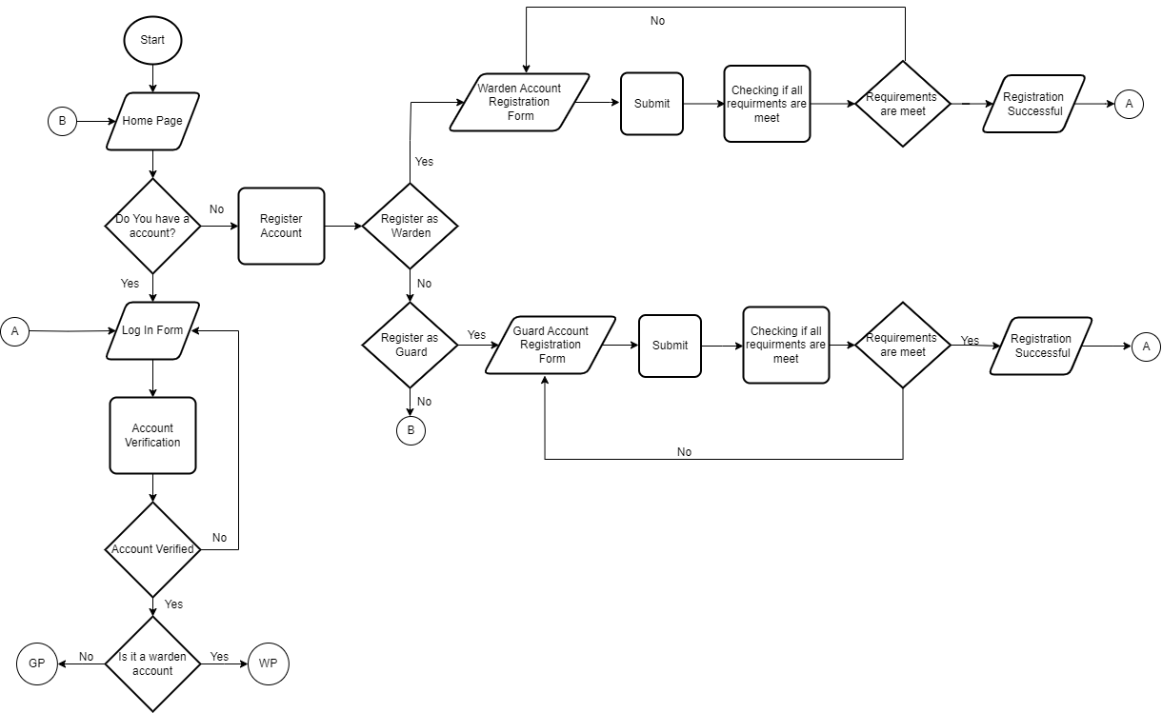

**Figure 2. Flowchart of Login & Registration Page in Web**

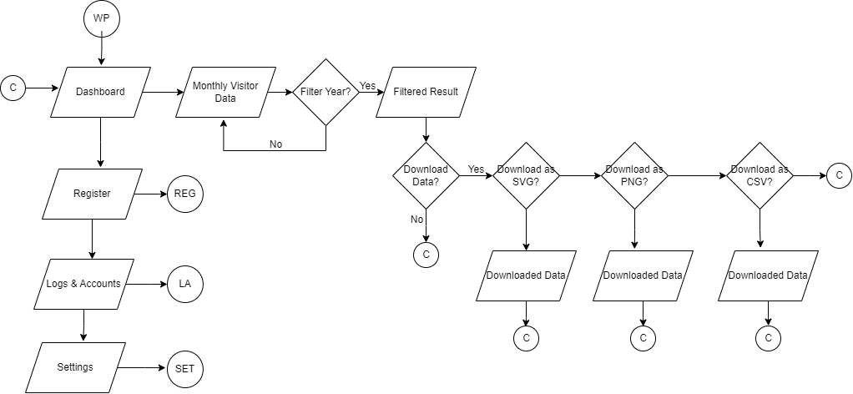

**Figure *3*. Flowchart of Dashboard (Warden)**

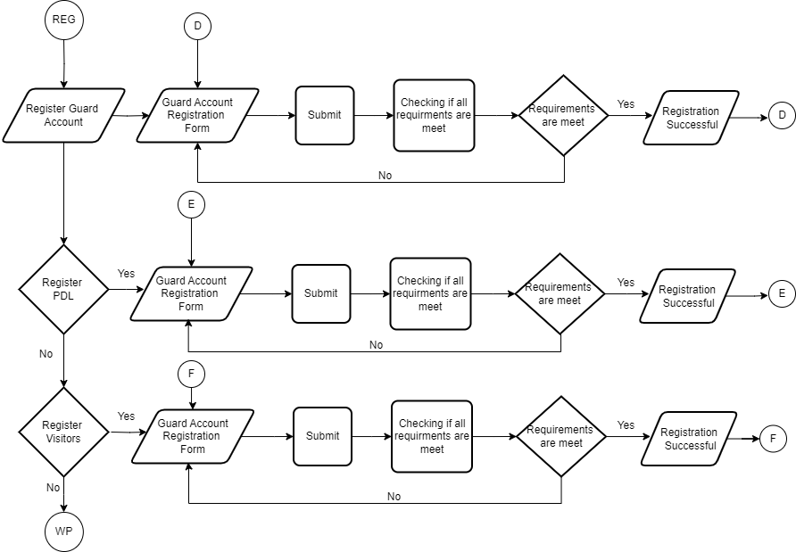

**Figure *4*. Flowchart of Registration (Warden)**

**Figure *5*. Flowchart of Logs & Account (Warden)**

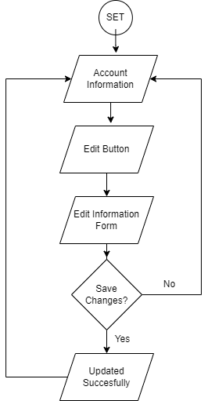

**Figure *6*. Flowchart of Settings (Warden)**

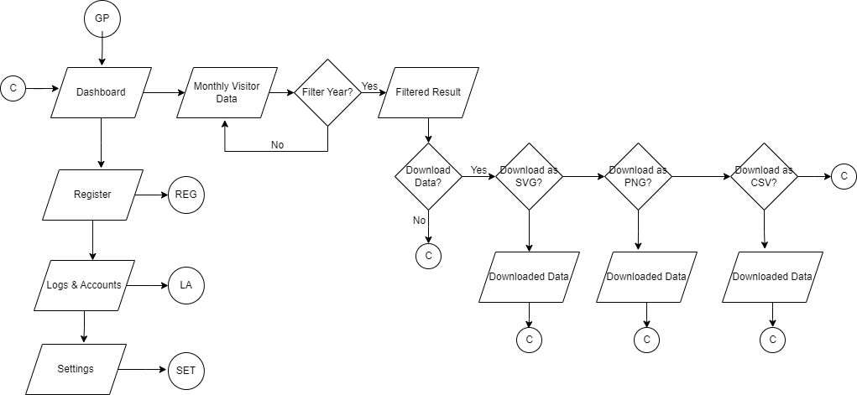

**Figure *7*. Flowchart of Dashboard (Guard)**

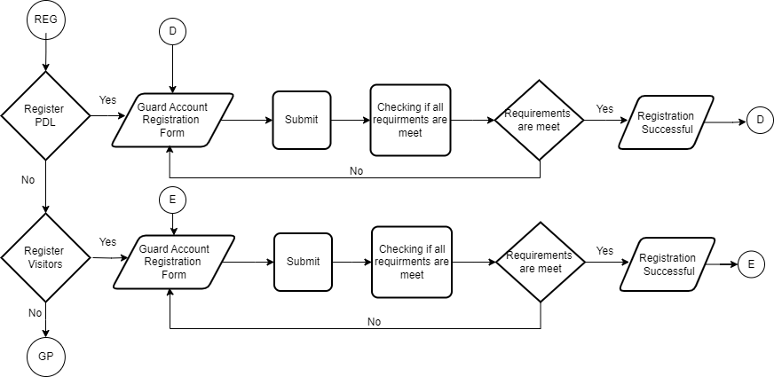

**Figure *8*. Flowchart of Registration (Guard)**

**Figure *9*. Flowchart of Logs & Account (Guard)**

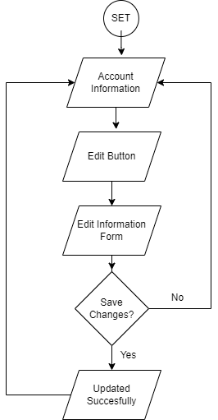

**Figure *10*. Flowchart of Settings (Guard)**

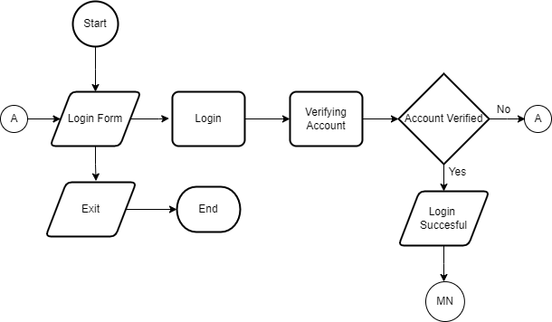

**Figure *11*. Flowchart of Login Page in Application**

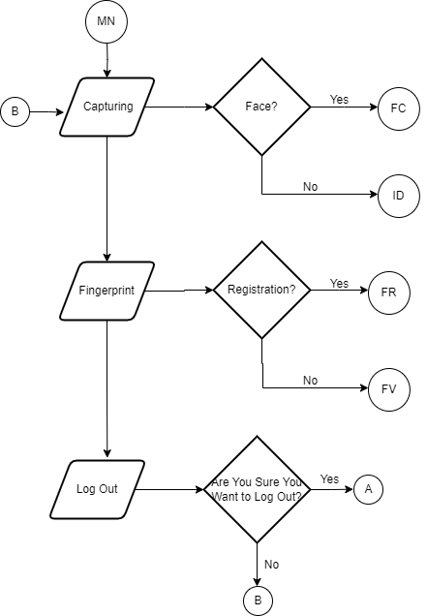

**Figure 12. Flowchart of Main Menu in Application**

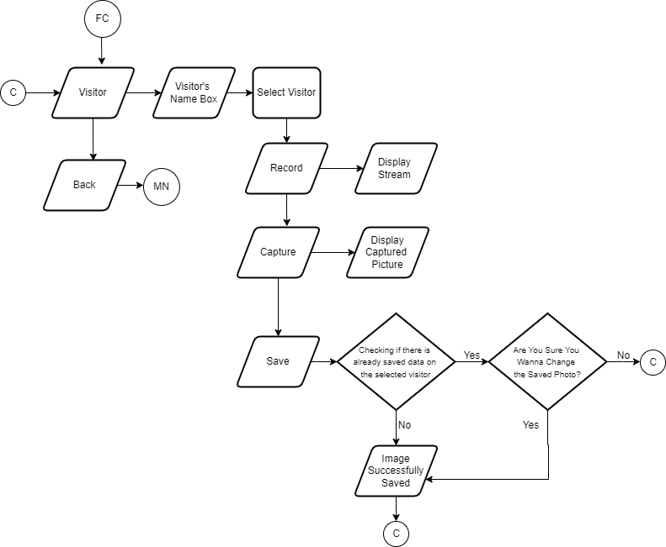

**Figure 13. Flowchart of Visitor Face Capture in Application**

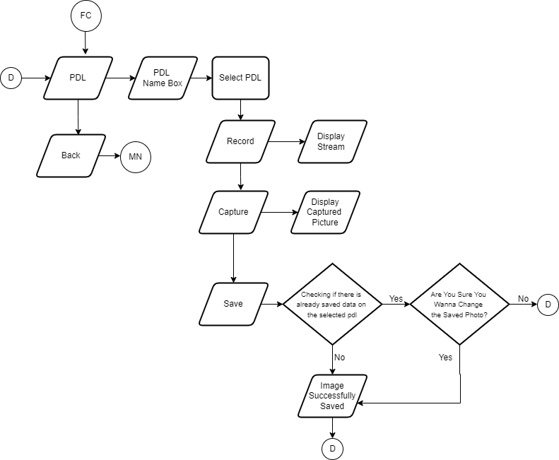

**Figure *14*. Flowchart of PDL Face Capture in Application**

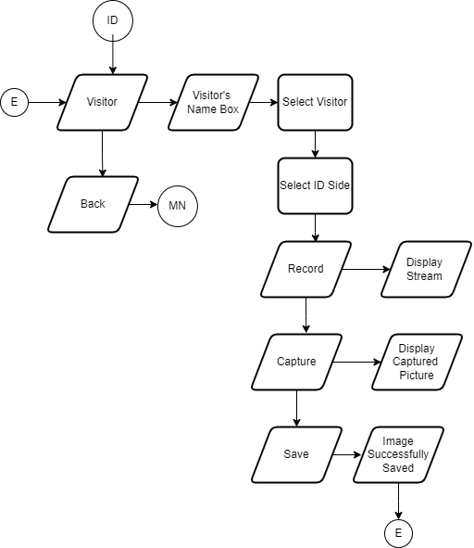

**Figure 15. Flowchart of ID Capturing in Application**

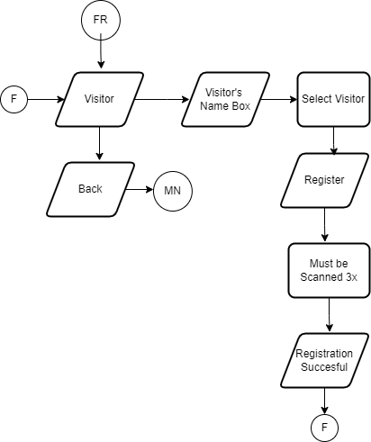

**Figure *16*. Flowchart of Fingerprint Registration in Application**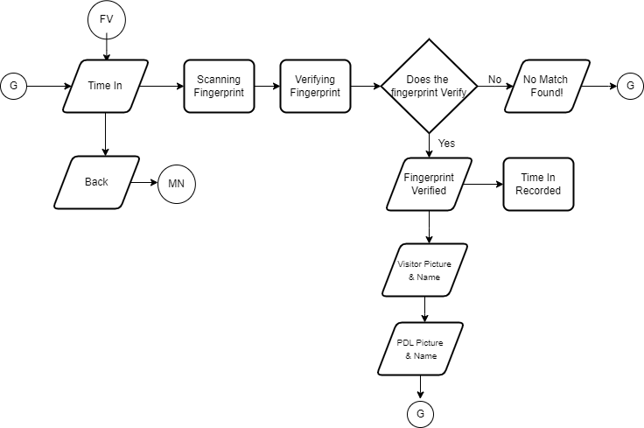

**Figure *17*. Flowchart of Time in Fingerprint Verification in Application**

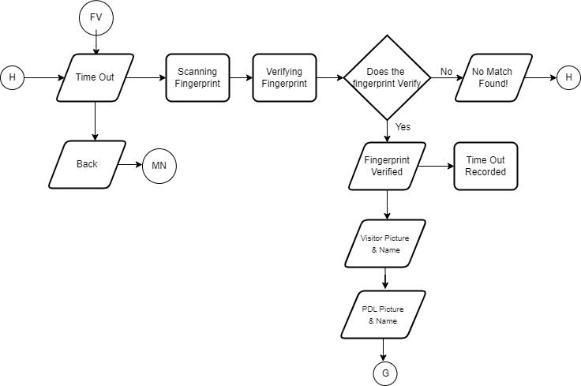

**Figure *18*. Flowchart of Time out Fingerprint Verification in Application**

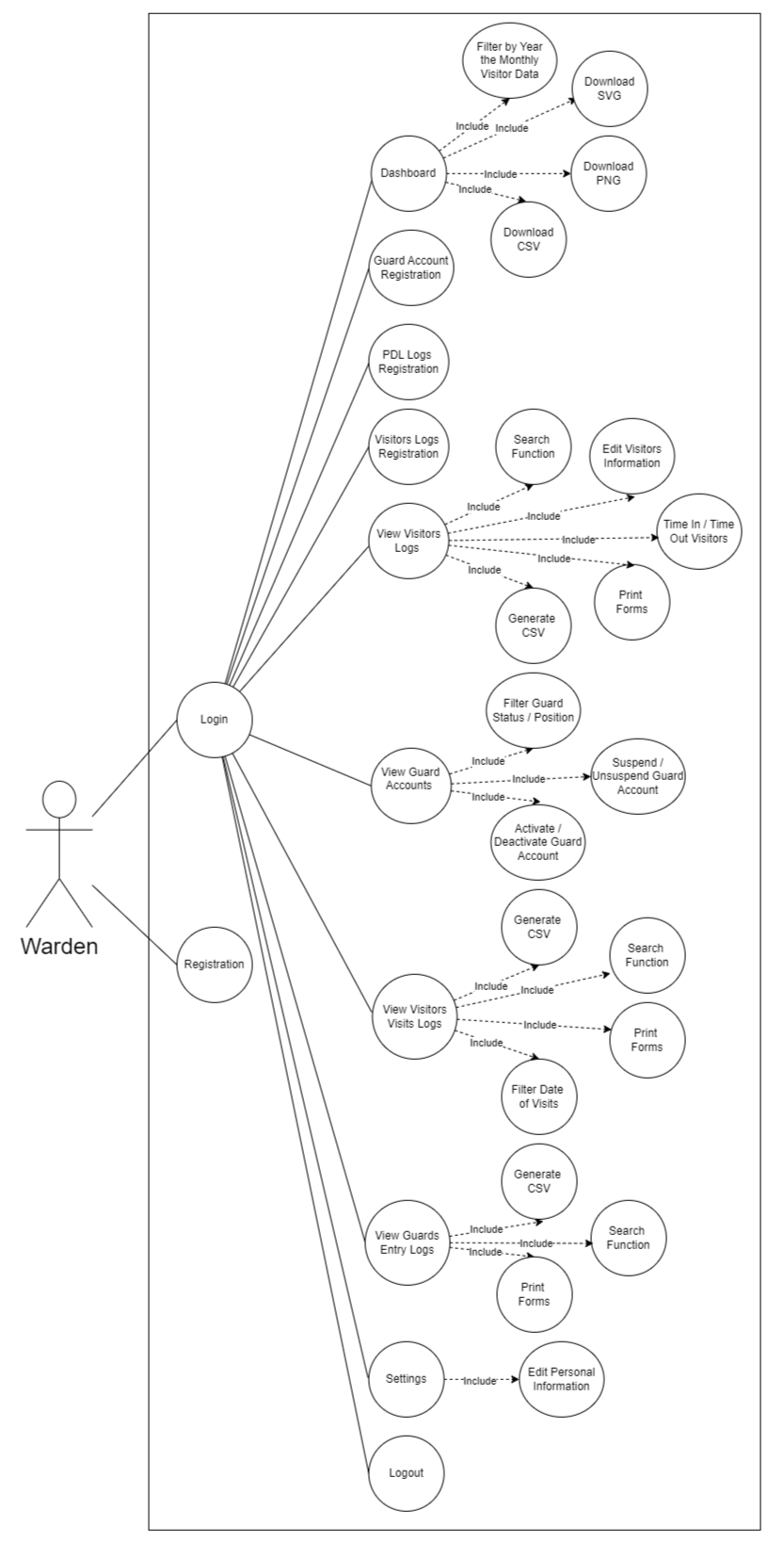**Figure *19*. Use-case diagram of the web system - Warden**

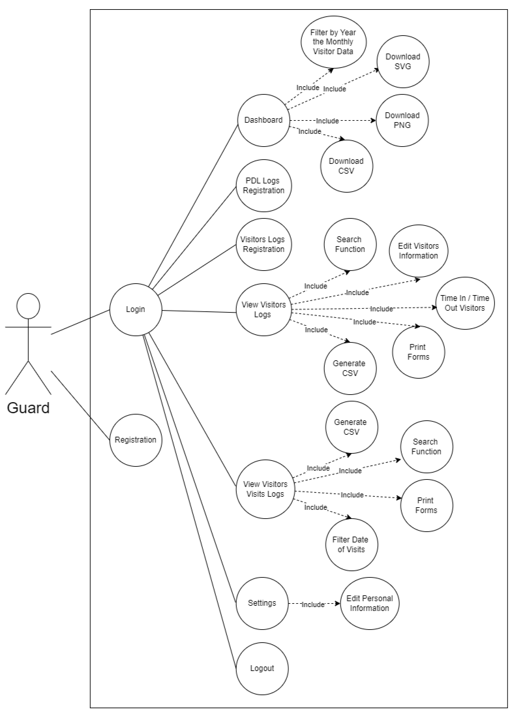

**Figure *20*. Use-case diagram of the web system - Guard**

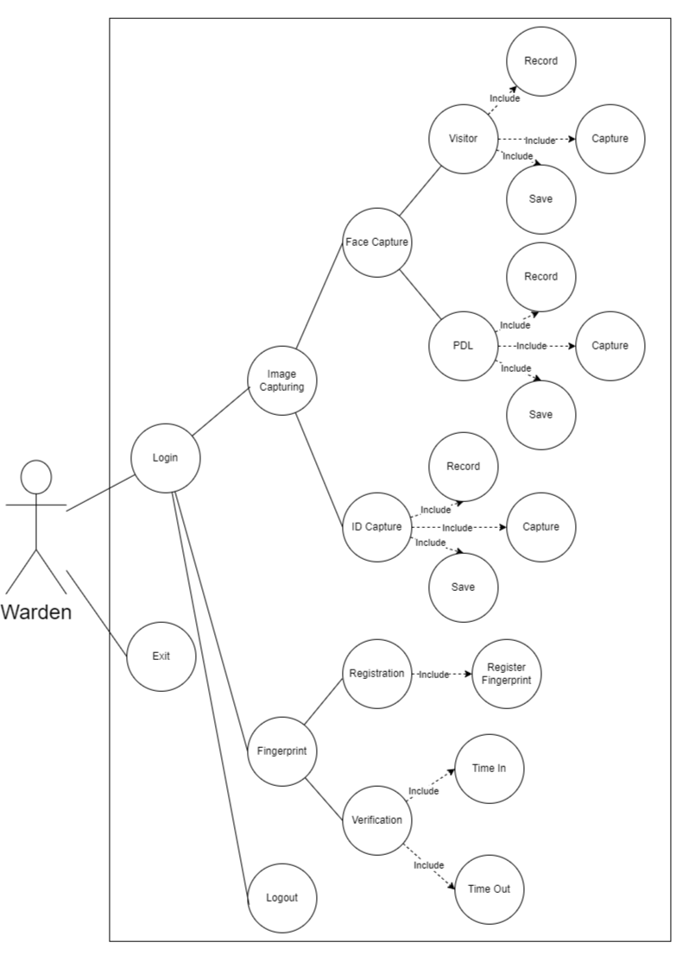

**Figure *21*. Use-case diagram of the application system - Warden**

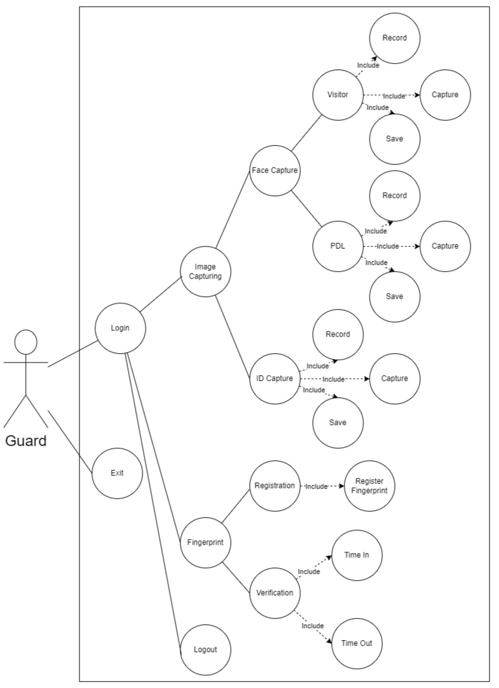

**Figure *22*. Use-case diagram of the application system - Guard**

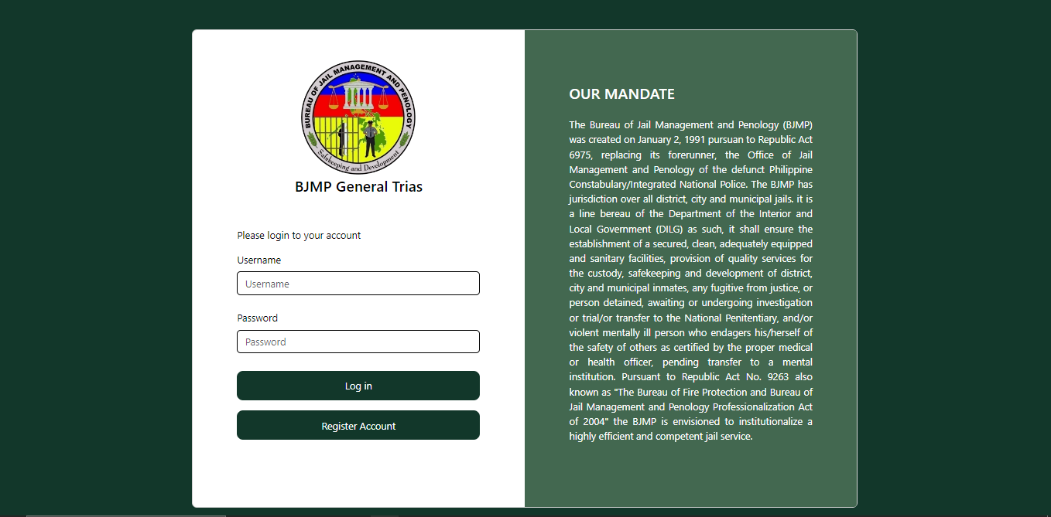

***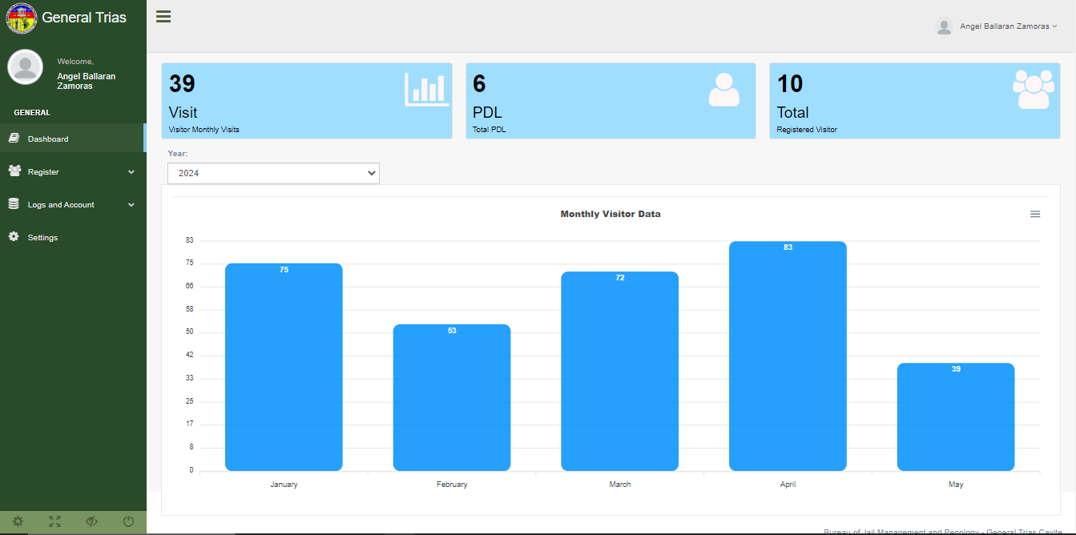*Figure *23*. Login Page**

**Figure 24. Dashboard**

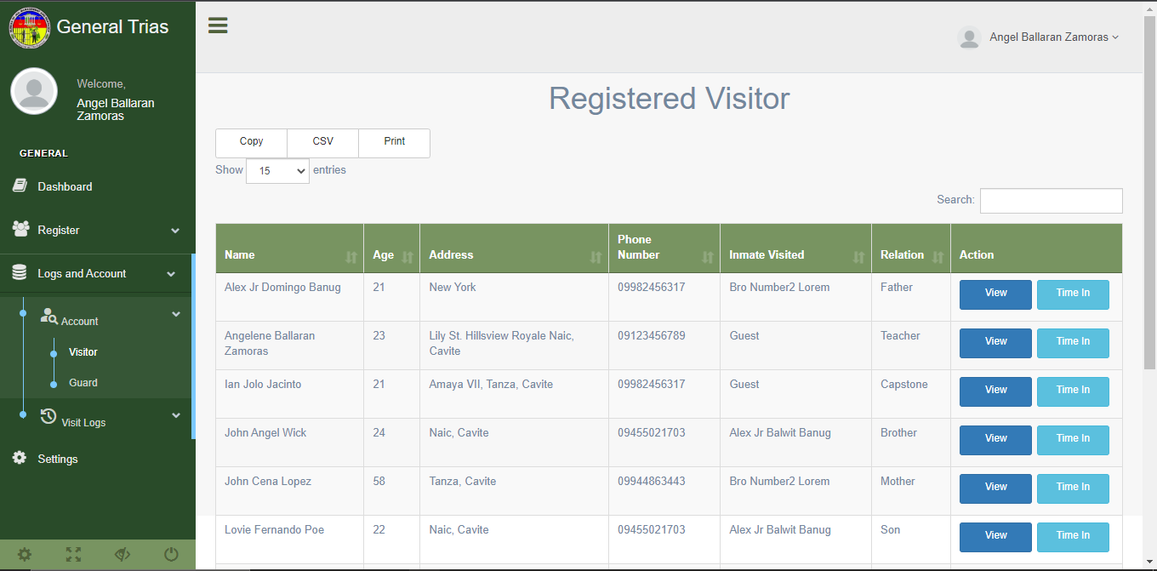

**Figure *25*. Registered Accounts**

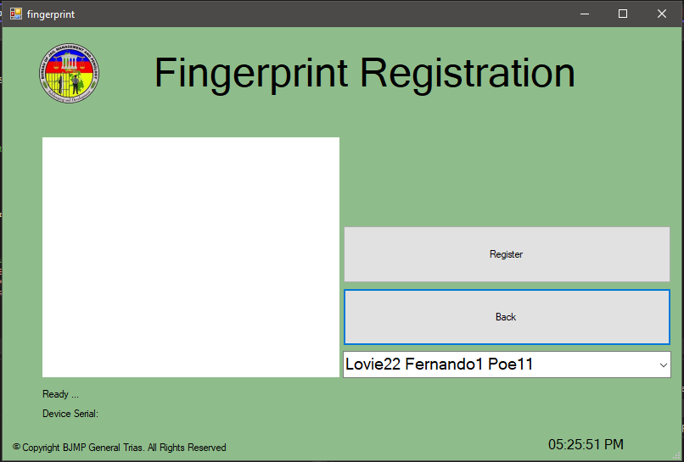

**Figure *26*. Fingerprint Registration**

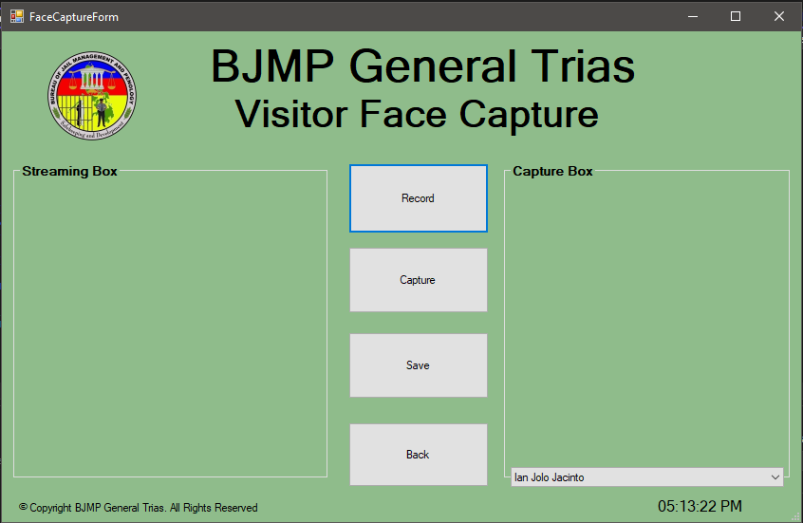

**Figure *27*. Face Capturing**

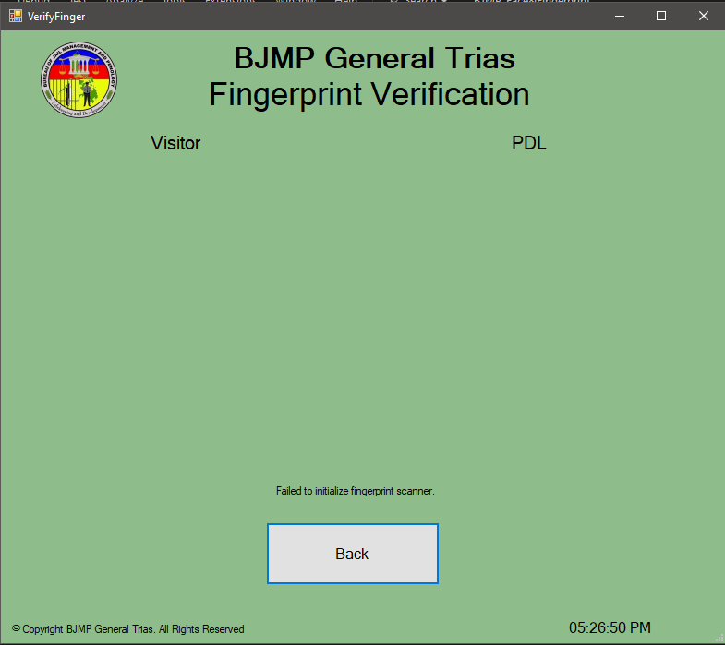

**Figure *28*. Time In**

### **Requirement Analysis**

The researcher should identify the details and functions of the current system of the organization that they will study. It shall discuss and answer the following questions: who – the people who are involved; what – the business activity, where –the environment in which the work involved; when – the timing, and how – how the current procedures are performed. Diagrams to clearly describe the system requirements should be provided in this phase.

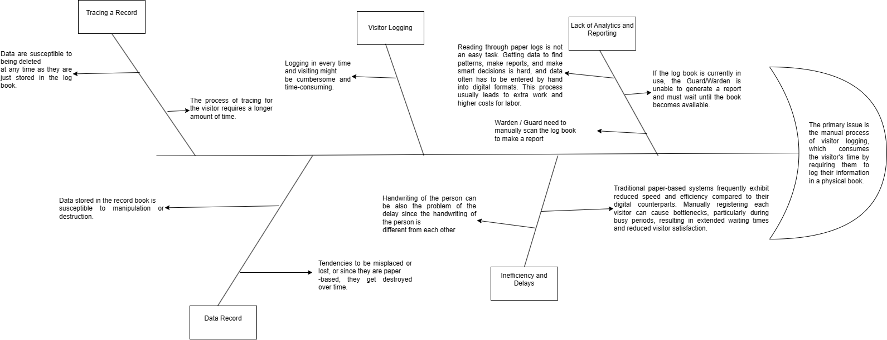

**Figure 29. Fishbone diagram of the system**

 Figure 29 shows the developer's fishbone diagram to explain the problem the client is experiencing. The main issue is that the logging system to enter the facility still relies on manual input, which consumes a lot of time just to fill out the required information. The fishbone diagram also shows the problems occurring because of the main issue, which include a lack of analytics and reporting, record tracing, inefficiency and delays, and data records. All of the subproblems have their description.

Table 1 presents the list of technical resources available in the organization that can be used to run the system to be developed.

**Table 1. List of technical resources available in the organization**

|  |  |
| --- | --- |
| **LIST OF RESOURCES AVAILABLE** | **STATUS** |
| 3 units of Personal Computer | Working |
| 1 Laptop | Working |
| 3-in-1 Printer | Working |
| Handheld Scanner | Working |
| Digital Camera | Working |

Table 2 presents the estimated cost of the system development.

**Table 2. Estimated cost of the system**

|  |  |
| --- | --- |
| **LIST OF EQUIPMENT** | **COST** |
| PC | PhP 7,000.00 |
| Smart Phone | PhP 0,000.00 |
| Fingerprint Scanner | PhP 1,800.00 |
| **TOTAL COST** | PhP 0,000.00 |

### **Requirement Documentation**

This documentation provides a full description of the system's functionality.

* **Registration Page**
* **Login Page**

## **System Development**

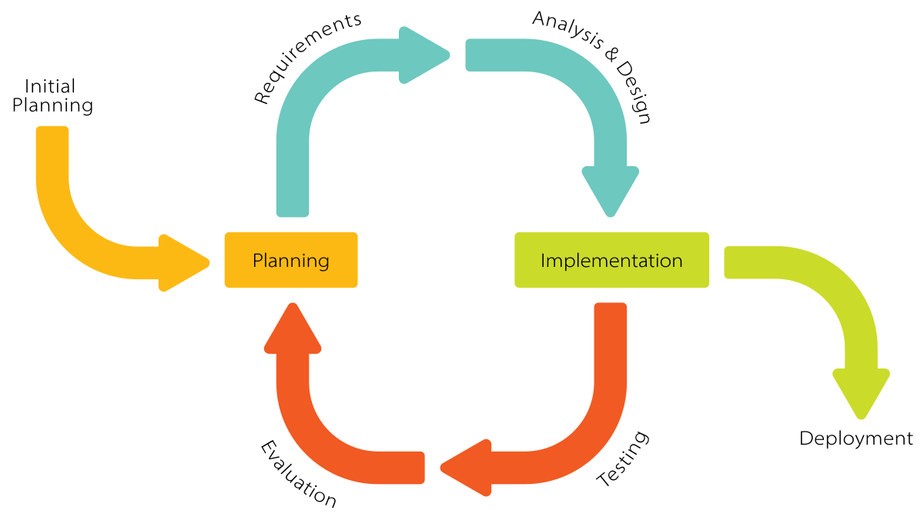The system was developed using Iterative Model that is shown on figure 30. This form of methodology helps the developers

**Figure *30*. Software methodology of the system using Iterative Model**

**Discuss each phase of the RAD – requirement planning, user design (prototype, test, redefine), construction, and cutover. (For Computer Science Thesis, discuss the dataset collection, model building, model validation, model deployment to the application or system)**

## **System Testing**

The overall system was tested to ensure that all of the functionalities were performing correctly and that they could execute the task assigned to those said functionalities. The system testing includes evaluating the functionality, performance, reliability, and other indicators to ensure that the system can serve its purpose.

**System Evaluation**

The system was evaluated based on modified ISO/IEC 25010 Software and Data Quality Evaluation Instrument. This is in terms of functional suitability, performance efficiency, compatibility, interaction capability, reliability, security, maintainability, flexibility, and safety as shown and n Table 3.

**Table 3. Software and data quality evaluation instrument**

|  |  |  |  |  |  |  |  |  |  |
| --- | --- | --- | --- | --- | --- | --- | --- | --- | --- |
| **INDICATOR** | **5** | | **4** | | **3** | | **2** | | **1** |
| **A. Functional Suitability** | | | | | | | | | |
| 1. ***Functional completeness*** - degree to which the set of functions covers all the specified tasks and intended users' objectives. |  |  | |  | |  | |  | |
| 1. ***Functional correctness*** - degree to which a product or system provides accurate results when used by intended users. |  |  | |  | |  | |  | |
| 1. ***Functional appropriateness*** - degree to which the functions facilitate the accomplishment of specified tasks and objectives. |  |  | |  | |  | |  | |
| **B. Performance Efficiency** | | | | | | | | | |
| 1. ***Time behaviour*** - degree to which the response time and throughput rates of a product or system, when performing its functions, meet requirements. |  |  | |  | |  | |  | |
| 1. ***Resource utilization*** - degree to which the amounts and types of resources used by a product or system, when performing its functions, meet requirements. |  |  | |  | |  | |  | |
| 1. ***Capacity*** - degree to which the maximum limits of a product or system parameter meet requirements. |  |  | |  | |  | |  | |
| **C. Compatibility** | | | | | | | | | |
| 1. ***Co-existence*** - degree to which a product can perform its required functions efficiently while sharing a common environment and resources with other products, without detrimental impact on any other product. |  |  | |  | |  | |  | |
| 1. ***Interoperability*** - degree to which a system, product or component can exchange information with other products and mutually use the information that has been exchanged. |  |  | |  | |  | |  | |
| **D. Interaction Capability** | | | | | | | | | |
| 1. ***Appropriateness recognizability*** - degree to which users can recognize whether a product or system is appropriate for their needs. |  |  | |  | |  | |  | |
| 1. ***Learnability*** - degree to which the functions of a product or system can be learnt to be used by specified users within a specified amount of time. |  |  | |  | |  | |  | |
| 1. ***Operability***- degree to which a product or system has attributes that make it easy to operate and control. |  |  | |  | |  | |  | |
| 1. ***User error protection*** - degree to which a system prevents users against operation errors. |  |  | |  | |  | |  | |
| 1. ***User engagement*** - degree to which a user interface presents functions and information in an inviting and motivating manner encouraging continued interaction. |  |  | |  | |  | |  | |
| 1. ***Inclusivity*** - degree to which a product or system can be used by people of various backgrounds (such as people of various ages, abilities, cultures, ethnicities, languages, genders, economic situations, etc.). |  |  | |  | |  | |  | |
| 1. ***User assistance*** - degree to which a product can be used by people with the widest range of characteristics and capabilities to achieve specified goals in a specified context of use. |  |  | |  | |  | |  | |
| 1. ***Self-descriptiveness*** -degree to which a product presents appropriate information, where needed by the user, to make its capabilities and use immediately obvious to the user without excessive interactions with a product or other resources (such as user documentation, help desks or other users). |  |  | |  | |  | |  | |
| **E. Reliability** | | | | | | | | | |
| 1. ***Faultlessness*** - degree to which a system, product or component performs specified functions without fault under normal operation. |  |  | |  | |  | |  | |
| 1. ***Availability*** - degree to which a system, product or component is operational and accessible when required for use. 2. ***Fault tolerance*** - Degree to which a system, product or component operates as intended despite the presence of hardware or software faults. |  |  | |  | |  | |  | |
| 1. ***Recoverability*** - degree to which, in the event of an interruption or a failure, a product or system can recover the data directly affected and re-establish the desired state of the system. |  |  | |  | |  | |  | |
| **F. Security** | | | | | | | | | |
| 1. ***Confidentiality*** - degree to which a product or system ensures that data are accessible only to those authorized to have access. |  |  | |  | |  | |  | |
| 1. *Integrity* - degree to which a system, product or component ensures that the state of its system and data are protected from unauthorized modification or deletion either by malicious action or computer error. |  |  | |  | |  | |  | |
| 1. ***Non-repudiation*** - degree to which actions or events can be proven to have taken place so that the events or actions cannot be repudiated later. |  |  | |  | |  | |  | |
| 1. ***Accountability -*** degree to which the actions of an entity can be traced uniquely to the entity. |  |  | |  | |  | |  | |
| 1. ***Authenticity*** - degree to which the identity of a subject or resource can be proved to be the one claimed. |  |  | |  | |  | |  | |
| 1. ***Resistance*** - degree to which the product or system sustains operations while under attack from a malicious actor. |  |  | |  | |  | |  | |
| **G. Maintainability** | | | | | | | | | |
| 1. ***Modularity*** - degree to which a system or computer program is composed of discrete components such that a change to one component has minimal impact on other components. |  |  | |  | |  | |  | |
| 1. ***Reusability*** - degree to which a product can be used as an asset in more than one system, or in building other assets. |  |  | |  | |  | |  | |
| 1. ***Analyzability*** - degree of effectiveness and efficiency with which it is possible to assess the impact on a product or system of an intended change to one or more of its parts, to diagnose a product for deficiencies or causes of failures, or to identify parts to be modified. |  |  | |  | |  | |  | |
| 1. ***Modifiability*** - degree to which a product or system can be effectively and efficiently modified without introducing defects or degrading existing product quality. |  |  | |  | |  | |  | |
| 1. ***Testability*** - degree of effectiveness and efficiency with which test criteria can be established for a system, product or component and tests can be performed to determine whether those criteria have been met. |  |  | |  | |  | |  | |
| **H. Flexibility** | | | | | | | | | |
| 1. ***Adaptability*** - degree to which a product or system can effectively and efficiently be adapted for or transferred to different hardware, software or other operational or usage environments. |  |  | |  | |  | |  | |
| 1. ***Scalability*** - degree to which a product can handle growing or shrinking workloads or to adapt its capacity to handle variability. |  |  | |  | |  | |  | |
| 1. ***Installability*** - degree of effectiveness and efficiency with which a product or system can be successfully installed and/or uninstalled in a specified environment. |  |  | |  | |  | |  | |
| 1. ***Replaceabilit***y - degree to which a product can replace another specified software product for the same purpose in the same environment. |  |  | |  | |  | |  | |
| 1. **Safety** | | | | | | | | | |
| 1. ***Operational constraint*** - degree to which a product or system constrains its operation to within safe parameters or states when encountering operational hazard. |  |  | |  | |  | |  | |
| 1. ***Risk identification*** - degree to which a product can identify a course of events or operations that can expose life, property or environment to unacceptable risk. |  |  | |  | |  | |  | |
| 1. ***Fail safe*** - degree to which a product can automatically place itself in a safe operating mode, or to revert to a safe condition in the event of a failure. |  |  | |  | |  | |  | |
| 1. ***Hazard warning*** - degree to which a product or system provides warnings of unacceptable risks to operations or internal controls so that they can react in sufficient time to sustain safe operations. |  |  | |  | |  | |  | |
| 1. ***Safe integration*** - degree to which a product can maintain safety during and after integration with one or more components. |  |  | |  | |  | |  | |

**Data analysis plan.** For the data analysis of data, Table 4 shows the descriptive interpretation of the mean.

**Table 4. Descriptive interpretation of the mean**

|  |  |
| --- | --- |
| **NUMERICAL SCALE** | **DESCRIPTIVE INTERPRETATION** |
| 4.51 – 5.00 | Excellent |
| 3.51 – 4.50 | Very Good |
| 2.51 – 3.50 | Good |
| 1.51 – 2.50 | Fair |
| 1.50 – below | Poor |

## **Implementation Plan**

Table 5 shows the implementation plan of the system

**Table 5. Implementation plan**

|  |  |  |  |
| --- | --- | --- | --- |
| **STRATEGY** | **ACTIVITIES** | **PERSONS INVOLVED** | **DURATION** |
| Approval from the company administrator | Letters | Researchers, Administrator | 1 day |
| System’s installation | Installation of the system and required software and hardware | Researchers, Administrator | 5 hours |
|  | Flyers | Administrator, Employee |  |
| Information distribution | Posters | Administrator, Employee | 1 day |
|  | Manuals | Administrator, Employee |  |
| 3-day training | Hands-on training and lectures | Administrator, Employee  Researcher | 3 days |

# **RESULTS AND DISCUSSION**

This chapter presents the results of the system design and development, the outcome of system testing and the results of system evaluation done by end users and IT professionals

## **System Design and Development**

Figure 31 shows the login screen for the guards and the wardens.



**Figure *31*. Login screen**

Figure 32 shows the registration page for warden account, the new warden will fill up the necessary information to complete the registration.

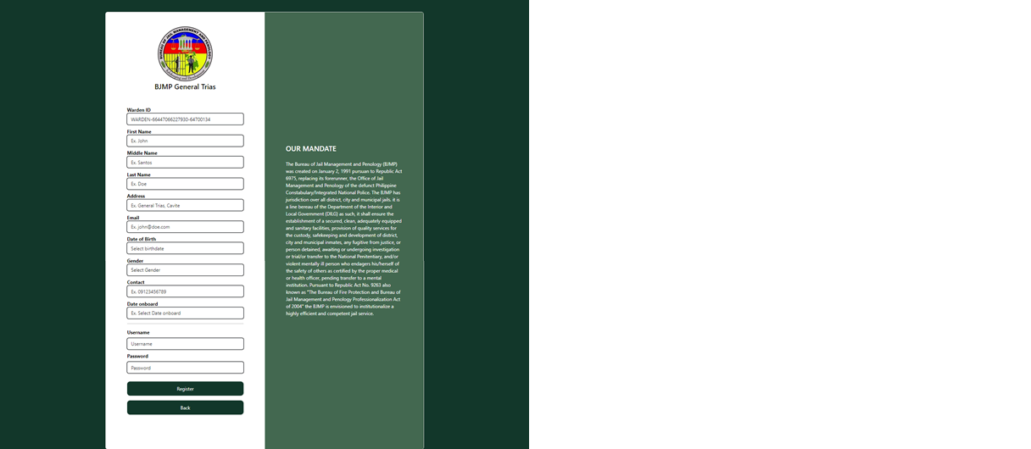

**Figure *32*. Warden Registration Form**

Figure 33 shows the registration page for guard account, the guards will fill up the necessary information to complete the registration.

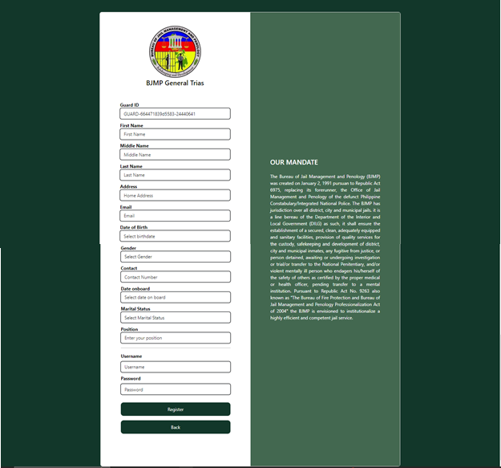

**Figure *33*. Guard Registration Form**

Figure 34 shows the dashboard in warden account it displays the number of visitors per month.



**Figure *34*. Warden Dashboard**

Figure 35 shows all of accounts that registered as warden and the current warden can choose what to activate.

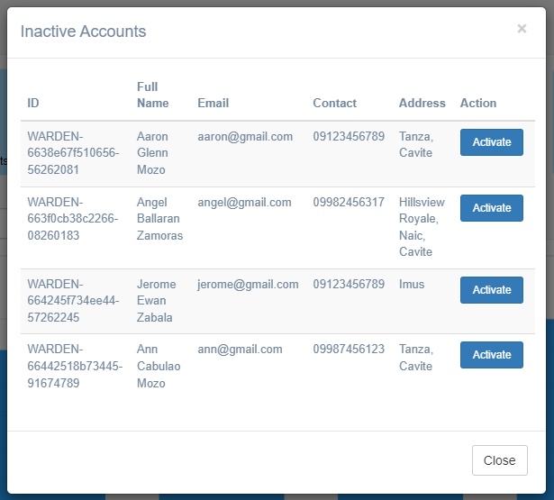

**Figure *35*. Inactive Accounts Notification (Warden)**

Figure 36 shows guard registration form the difference from the guard registration page is that upon registering an account direct by the warden it will be activated already.

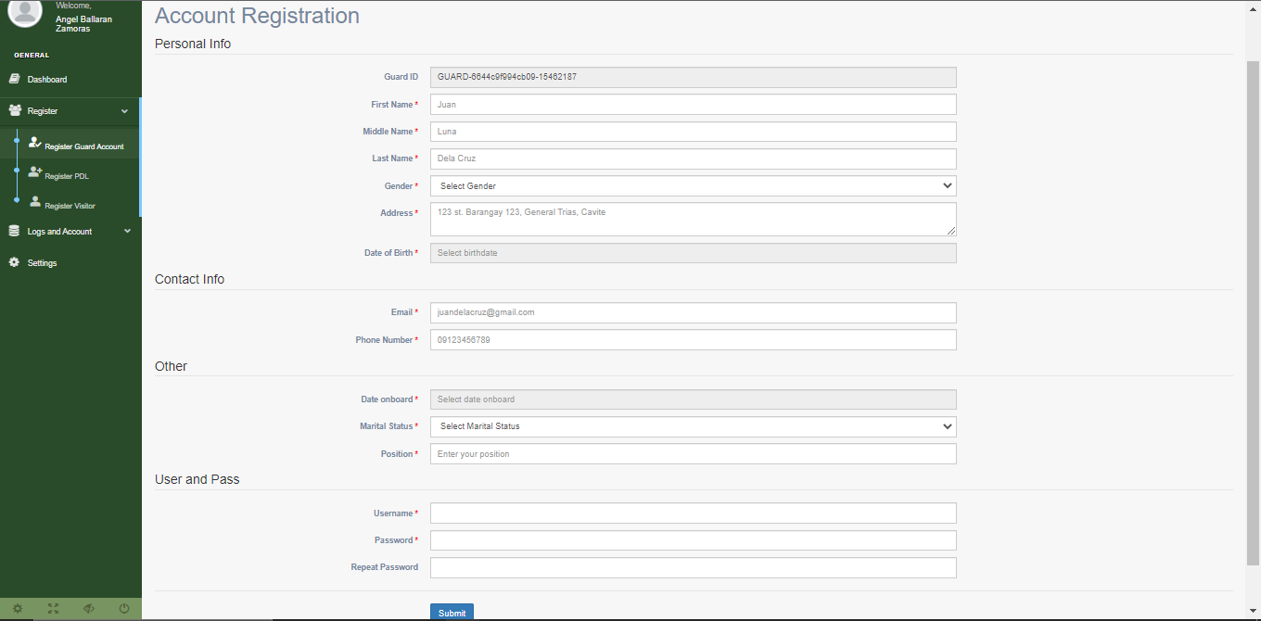

**Figure *36*. Guard Registration (Warden)**

Figure 37 shows the registration form where all of the pdl in the facility should be registered.

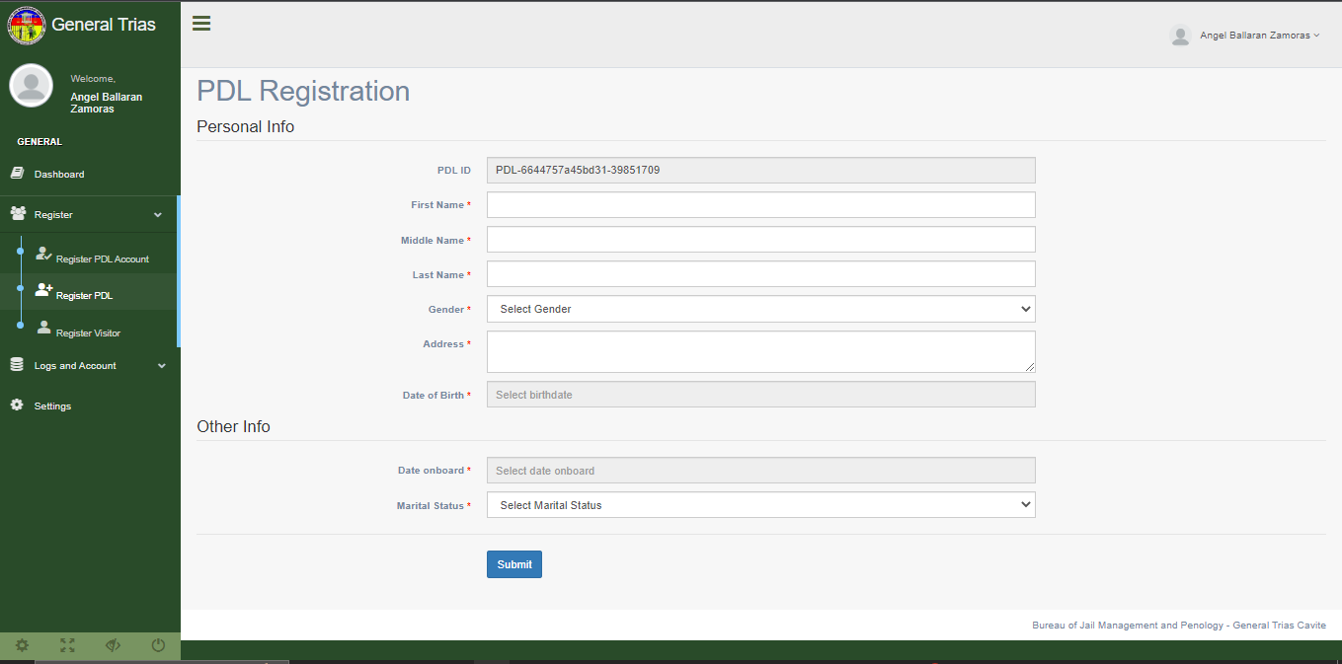

**Figure 37. PDL Registration (Warden)**

Figure 38 shows the registration form where all of the first-time visitors must need to be registered.

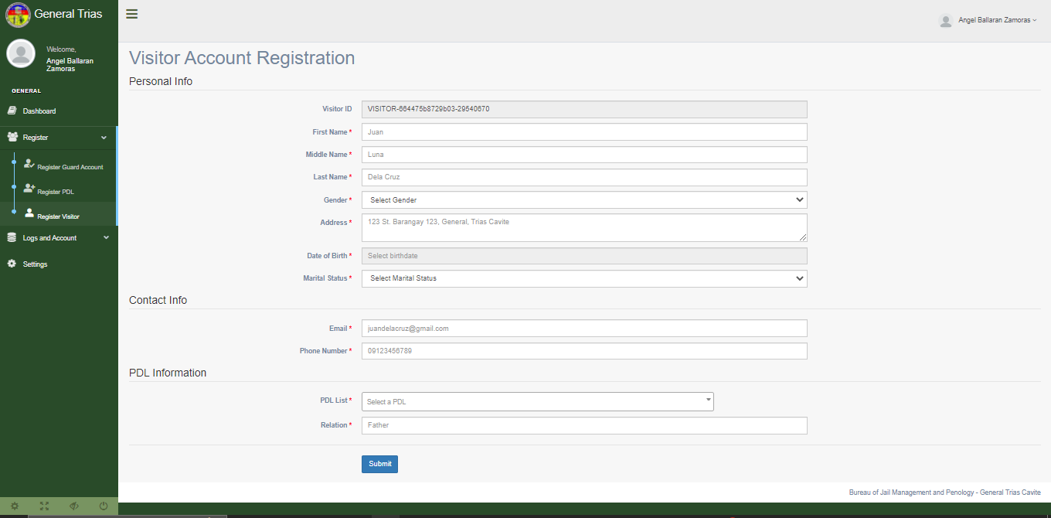

**Figure *38*. Visitor Registration (Warden)**

Figure 39 shows all of the registered visitors and the warden can view the information and edit that information and time-in and time-out manually the registered visitors.



**Figure *39*. Registered Visitors (Warden)**

Figure 40 shows all of the registered guard accounts and the warden has the capabilities to activate, deactivate, suspend, unsuspend and reset the password of the registered guard accounts.

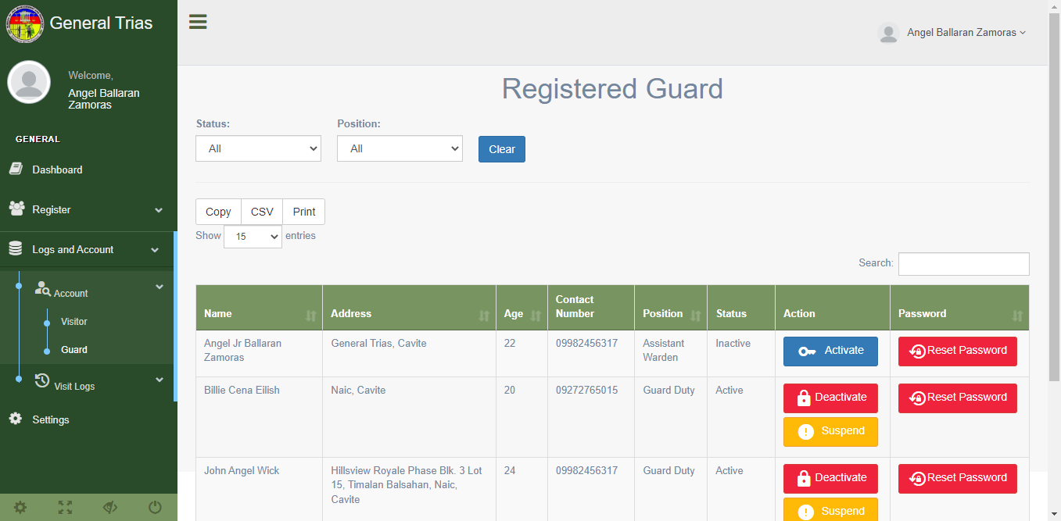

**Figure *40*. Registered Guard Accounts (Warden)**

Figure 41 shows the record of visitors that visits the facility and it has filter features and generate a report in the means of csv or print.

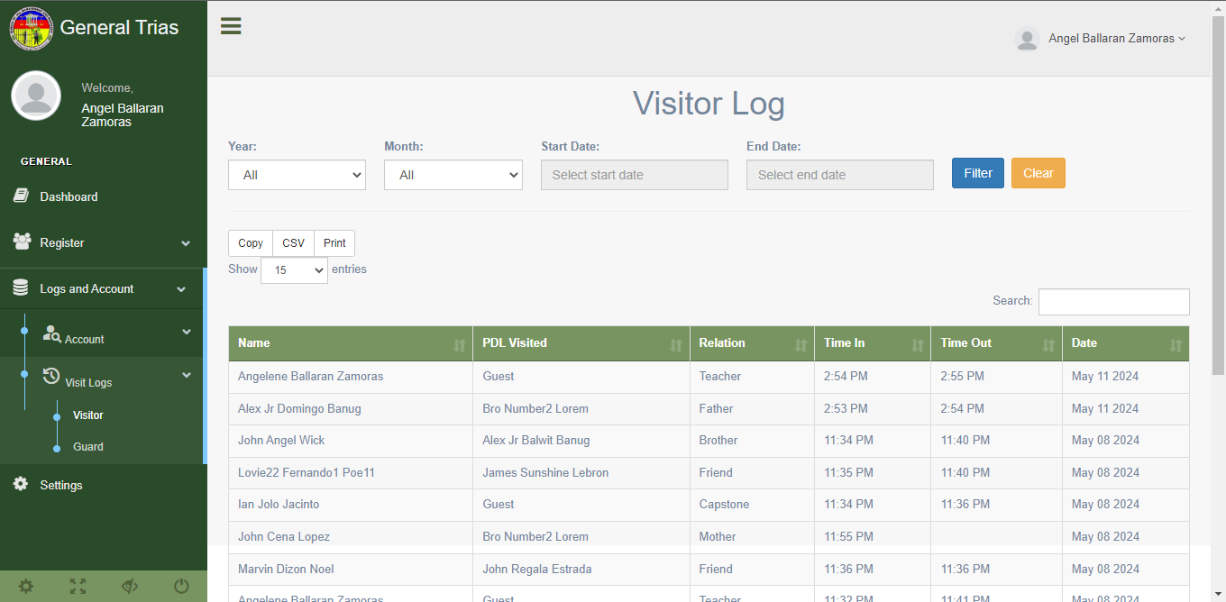

**Figure 41. Visitor Visits Logs (Warden)**

Figure 42 shows the record of guards that access the system and it has filter features and generate a report in the means of csv or print.

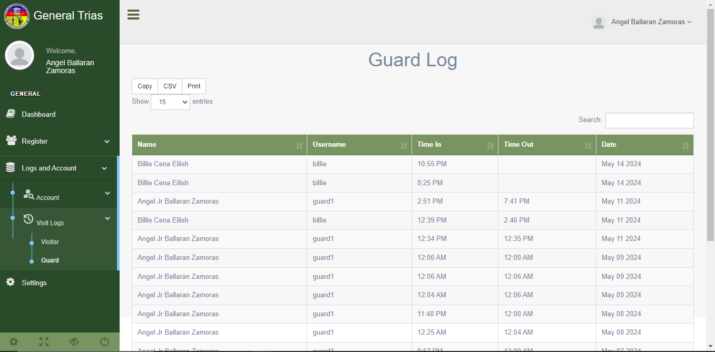

**Figure *42*. Guards Entry Logs (Warden)**

Figure 43 shows the settings page where the warden can edit some of the information of his/her account.

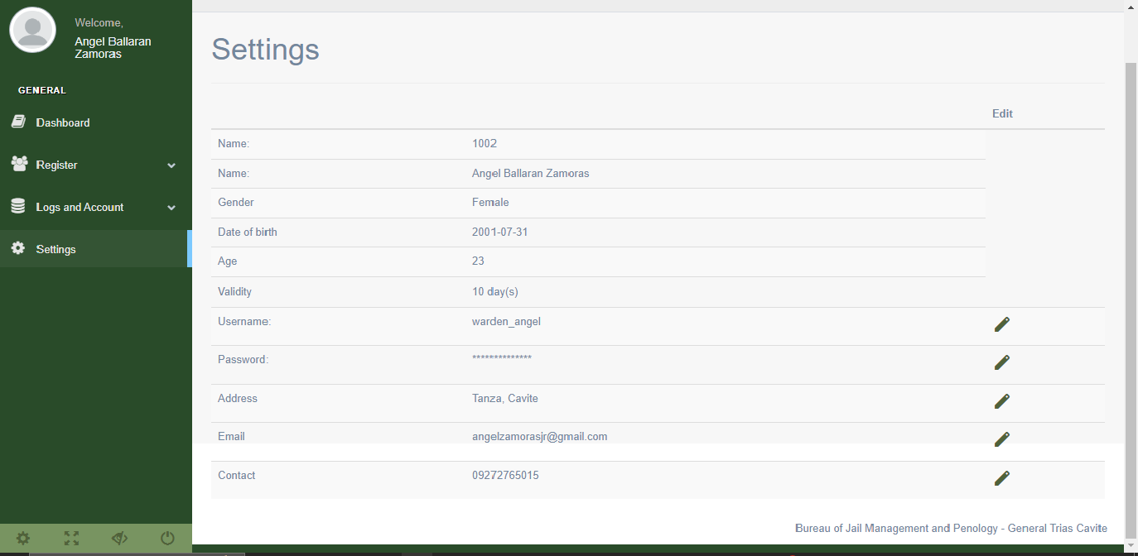

**Figure *43*. Settings (Warden)**

Figure 44 shows the dashboard in guard account it displays the number of visitors per month.

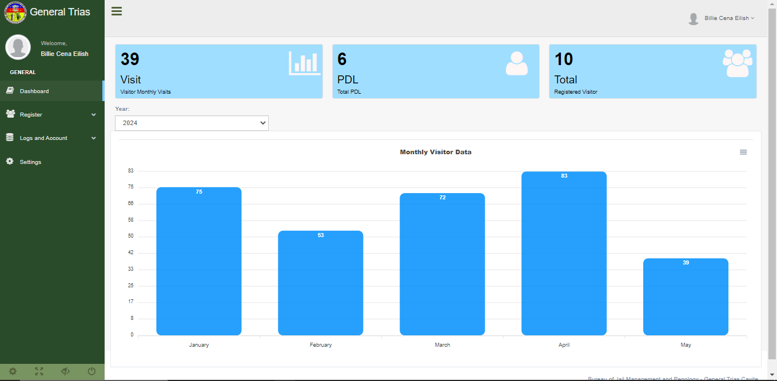

**Figure *44*. Dashboard (Guard)**

Figure 45 shows the registration form where all of the first-time visitors must need to be registered.

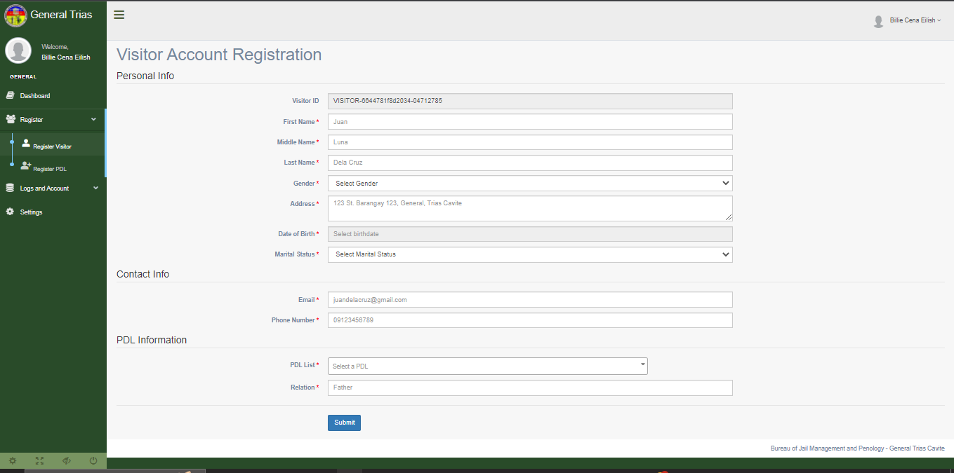

**Figure *45*. Visitor Registration (Guard)**

Figure 46 shows the registration form where all of the pdl in the facility should be registered.

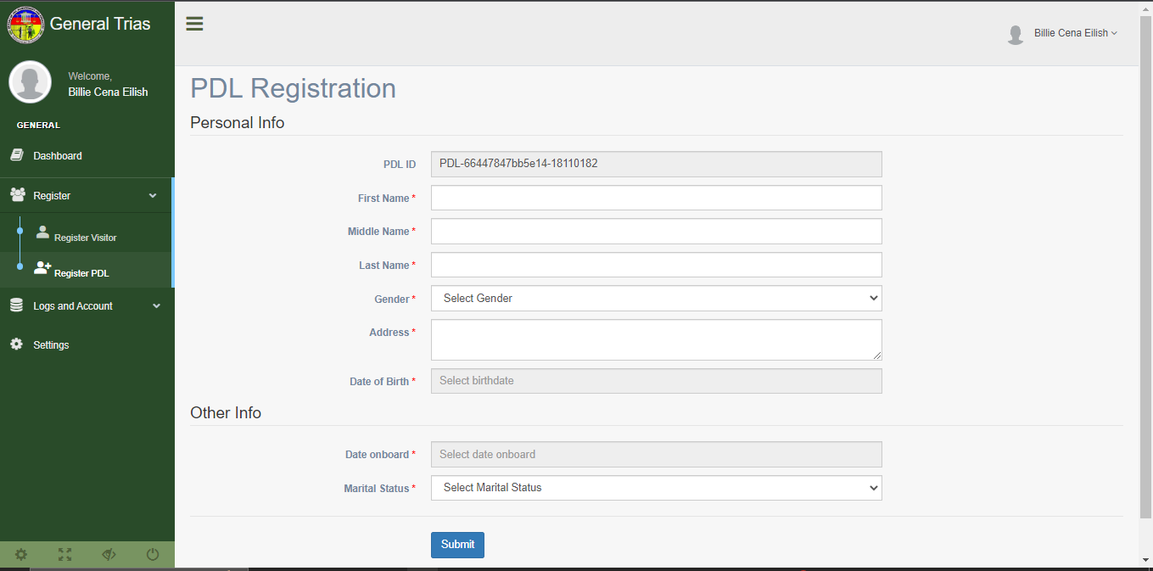

**Figure *46*. PDL Registration (Guard)**

Figure 47 shows all of the registered visitors and the guard can view the information and edit that information and time-in and time-out manually the registered visitors.

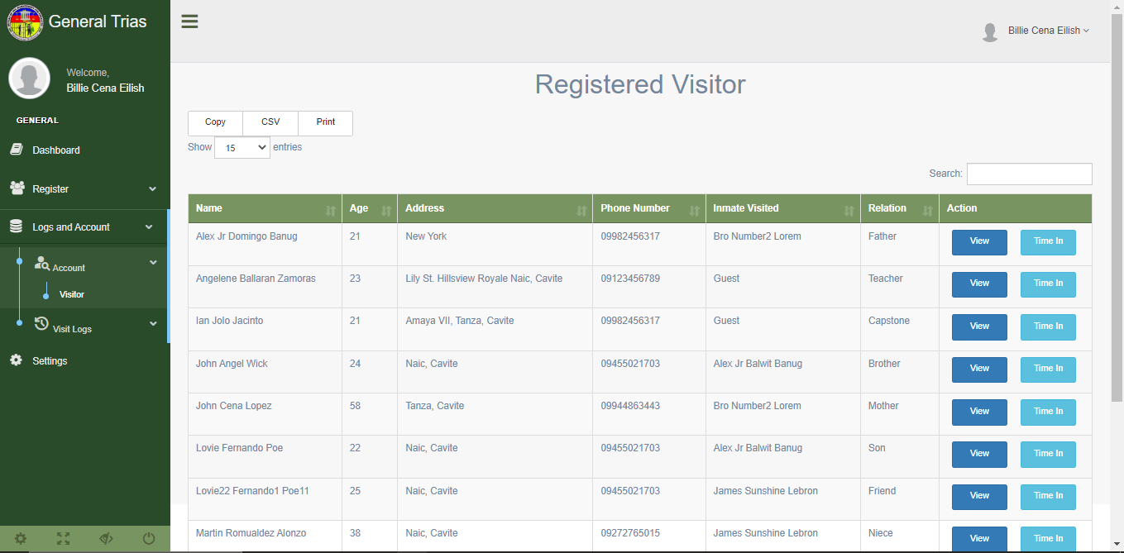

**Figure *47*. Registered Visitors (Guard)**

Figure 48 shows the record of visitors that visits the facility and it has filter features and generate a report in the means of csv or print.

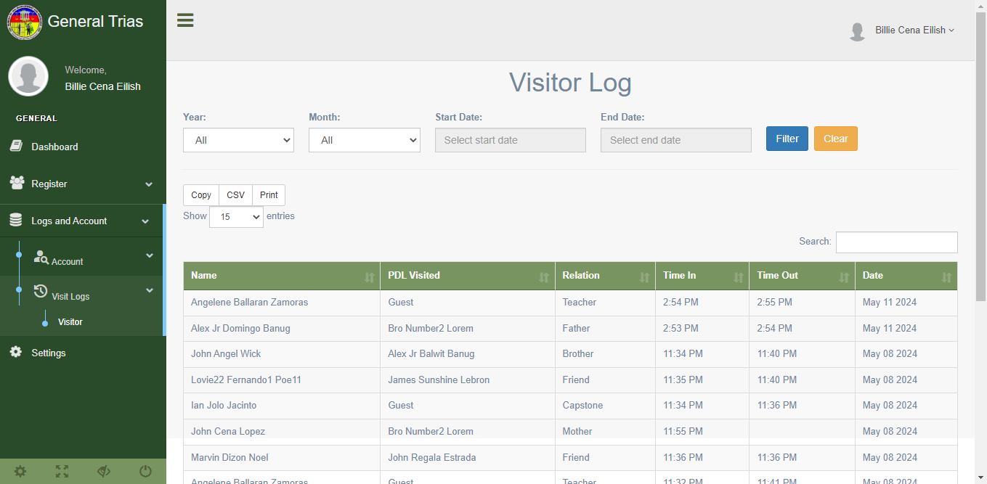

**Figure *48*. Visitor Visits Logs (Guard)**

Figure 49 shows the settings page where the guard can edit some of the information of his/her account.

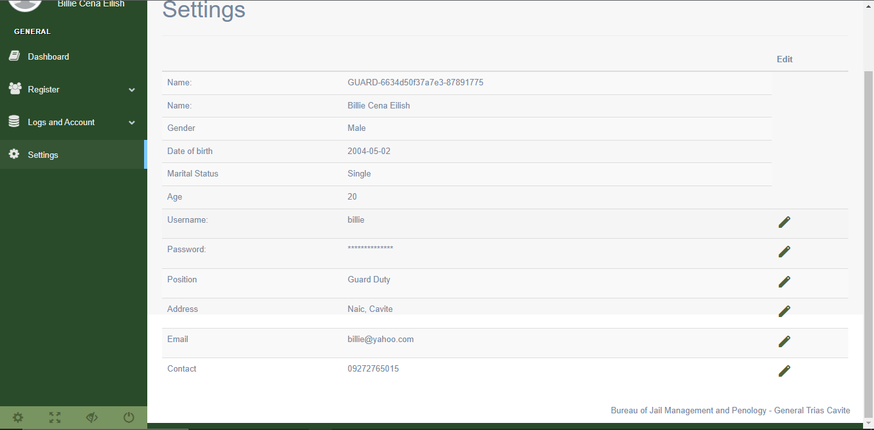

**Figure *49*. Settings (Guard**

Figure 50 shows the login screen of the application for face capturing and fingerprint registration.

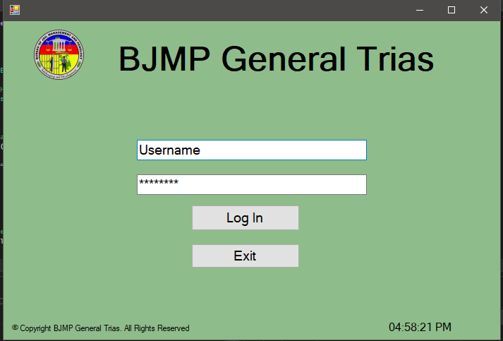

**Figure *50*. Log In (Application)**

Figure 51 shows the main menu of the application.

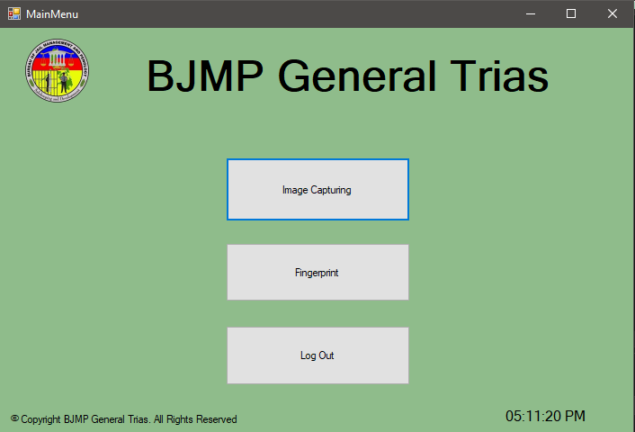

**Figure 5*1*. Main Menu (Application)**

Figure 52 shows the image capture menu of the application.

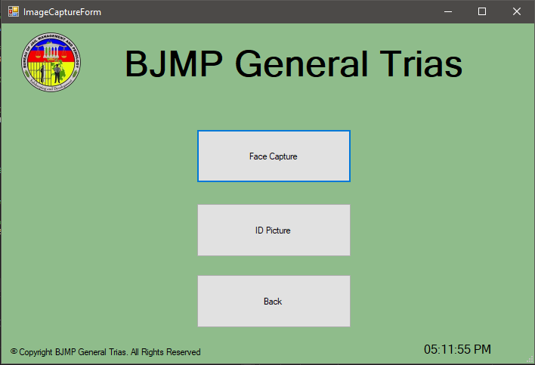

**Figure *52*. Image Capture Menu (Application)**

Figure 53 shows whether the face that would be capture is a visitor or a pdl.

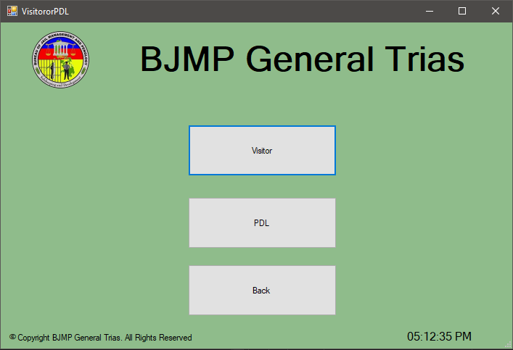

**Figure *53*. Face Capture Menu (Application)**

Figure 54 shows the ID capturing feature of the application.

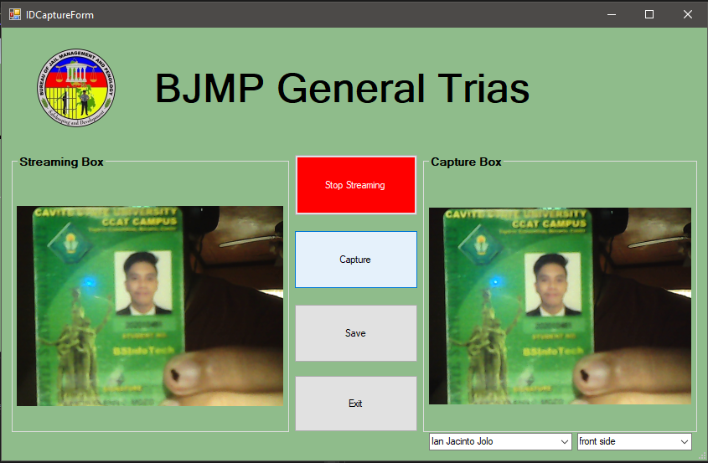

**Figure *54*. ID Capture (Application)**

Figure 55 shows the face capturing feature of the application for all of the registered visitors.

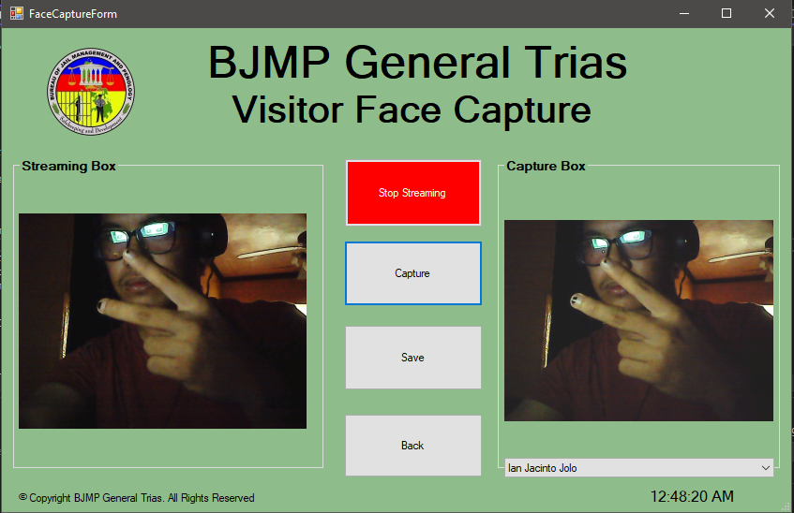

**Figure *55*. Visitor Face Capture (Application)**

Figure 56 shows the face capturing feature of the application for all of the registered pdl in the facility.

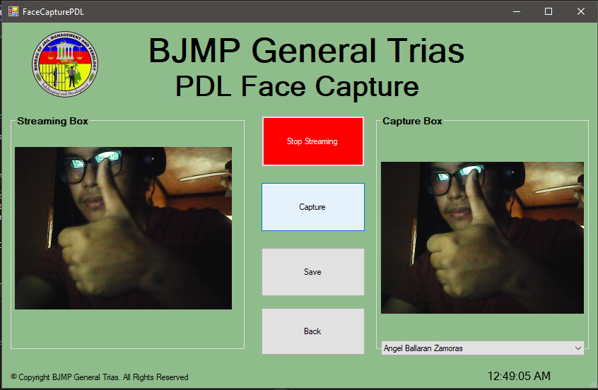

**Figure *56*. PDL Face Capture (Application)**

Figure 57 shows the fingerprint menu of the application.

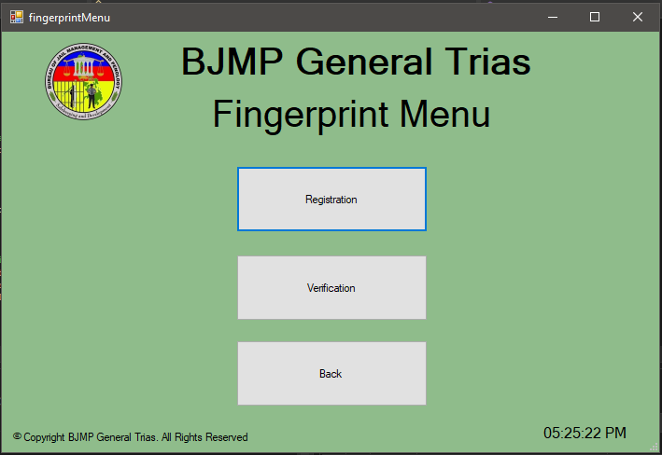

**Figure 57. Fingerprint Menu (Application)**

Figure 58 shows the fingerprint registration page of the application all of the registered visitors that don’t have fingerprint registered can be seen in the combo box.

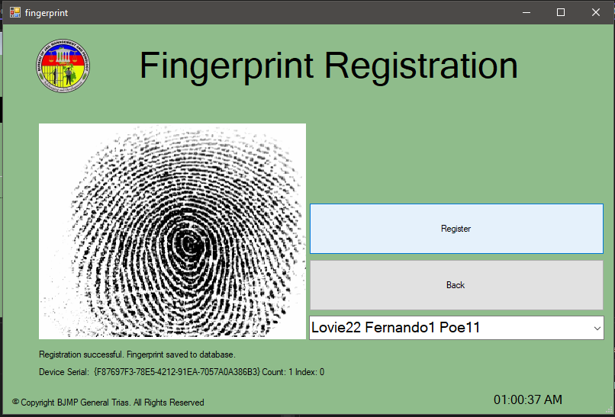

**Figure *58*. Fingerprint Registration (Application)**

Figure 59 shows the time in or time out menu of the application.

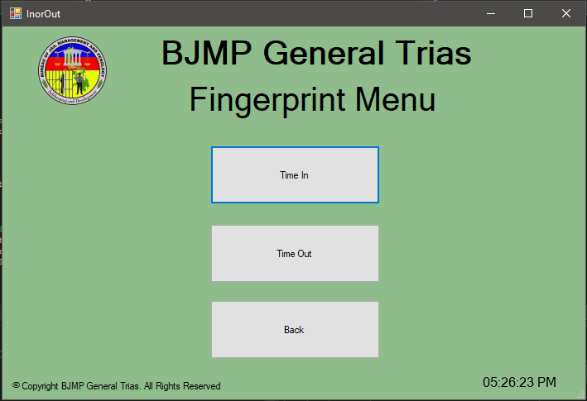

**Figure *59*. Fingerprint Verification Menu (Application)**

Figure 60 shows the time in feature of the application where the visitors must verify their registered fingerprint.

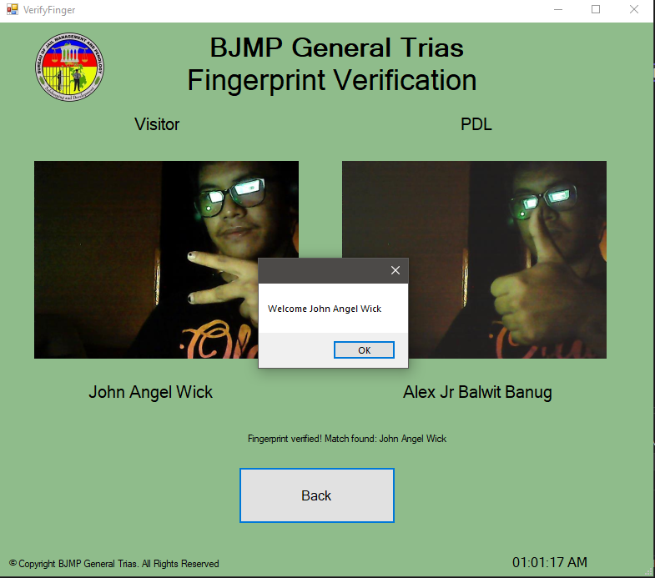

**Figure *60*. Time In (Application)**

Figure 61 shows the time out feature of the application where the visitors must verify their registered fingerprint.

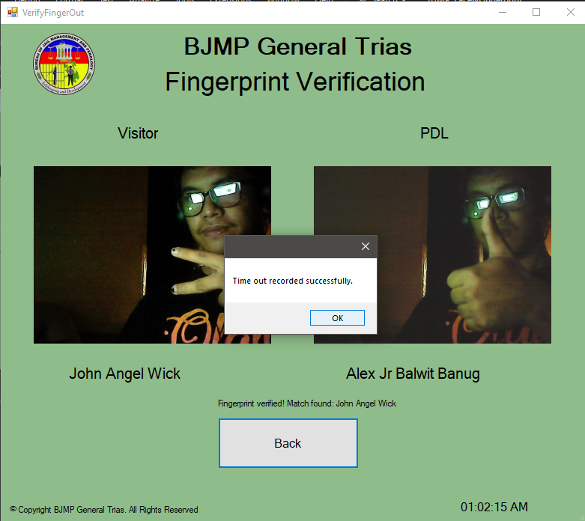

**Figure *61*. Time Out (Application)**

## **System Testing**

Table 6 shows the results of functional test of different modules of the system.

**Table 6. Functional testing**

|  |  |  |  |  |  |
| --- | --- | --- | --- | --- | --- |
| **Module** | **Login Page (Web)** | | | | |
| **Test Case** | **Action** | **Expected System Response** | **Number of Execution** | **Results** | **Status** |
| WLP01 | Click the “Login” button | If the account that was login was registered it will redirect to home page if not a message would pop up indication the account is not registered | 1 | Redirect to Home Page | Passed |
| WLP02 | Click the “Register Account” button | The system must show two (2) buttons one for warden and one for guard | 1 | Two buttons pop up one warden and one guard | Passed |
| WLP03 | Click the “Warden Account” button | The system must redirect to warden account registration | 1 | Redirected to warden account registration | Passed |
| WLP04 | Click the “Guard Account” button | The system must redirect to guard account registration | 1 | Redirected to guard account registration | Passed |

|  |  |  |  |  |  |
| --- | --- | --- | --- | --- | --- |
| **Module** | **Account Registration Page (Warden)** | | | | |
| **Test Case** | **Action** | **Expected System Response** | **Number of Execution** | **Results** | **Status** |
| WARP01 | Click the “Register” button | The system will prompt a message that the account was registered if the requirements are met and an error if not | 1 | A message shows successful registration / validation error | Passed |
| WARP02 | Click the “Back” button | The system must redirect to login page | 1 | Redirected to login page | Passed |

|  |  |  |  |  |  |
| --- | --- | --- | --- | --- | --- |
| **Module** | **Account Registration Page (Guard)** | | | | |
| **Test Case** | **Action** | **Expected System Response** | **Number of Execution** | **Results** | **Status** |
| GARP01 | Click the “Register” button | The system will prompt a message that the account was registered if the requirements are met and an error if not | 1 | A message shows successful registration / validation error | Passed |
| GARP02 | Click the “Back” button | The system must redirect to login page | 1 | Redirected to login page | Passed |

|  |  |  |  |  |  |
| --- | --- | --- | --- | --- | --- |
| **Module** | **Home Page (Warden)** | | | | |
| **Test Case** | **Action** | **Expected System Response** | **Number of Execution** | **Results** | **Status** |
| HPW01 | Click the “Dash Board Button” button | The system must redirect to dashboard | 1 | Redirected to dashboard | Passed |
| HPW02 | Click the “Register Button” button | The system must show three (3) buttons which are register guard account, register PDL and register visitor account | 1 | Three (3) buttons show up | Passed |
| HPW03 | Click the “Register Guard Account” button | The system must redirect to register guard account | 1 | Redirected to register guard account | Passed |
| HPW04 | Click the “Register PDL” button | The system must redirect to register PDL | 1 | Redirected to register PDL | Passed |
| HPW05 | Click the “Register Visitor” button | The system must redirect to Register Visitor Account | 1 | Redirected to register visitor account | Passed |
| HPW06 | Click the “Logs and Accounts” button | The system must show two (2) buttons which are accounts and visit logs | 1 | Two (2) buttons show up | Passed |
| HPW07 | Click the “Accounts” button | The system must show two (2) buttons which are visitor and guards | 1 | Two (2) buttons show up | Passed |
| HPW08 | Click the “Visitor” under accounts button | The system must redirect to Register Visitor Account | 1 | Redirected to registered visitor account | Passed |
| HPW09 | Click the “Guards” under accounts button | The system must redirect to Register Visitor Account | 1 | Redirected to registered guard account | Passed |
| HPW10 | Click the “Visits Logs” button | The system must show two (2) buttons which are visitor and guards | 1 | Two (2) buttons show up | Passed |
| HPW11 | Click the “Visitor” under visits logs button | The system must redirect to visitor visits logs | 1 | Redirected to visitor visits logs | Passed |
| HPW12 | Click the “Guards” under visits logs button | The system must redirect to guard entry logs | 1 | Redirected to guard entry logs | Passed |
| HPW13 | Click the “Settings” button | The system must redirect to settings | 1 | Redirected to settings | Passed |

|  |  |  |  |  |  |
| --- | --- | --- | --- | --- | --- |
| **Module** | **Home Page (Guard)** | | | | |
| **Test Case** | **Action** | **Expected System Response** | **Number of Execution** | **Results** | **Status** |
| HPG01 | Click the “Dash Board Button” button | The system must redirect to dashboard | 1 | Redirected to dashboard | Passed |
| HPG02 | Click the “Register Button” button | The system must show two (2) buttons which are register PDL and register visitor account | 1 | Two (2) buttons show up | Passed |
| HPW03 | Click the “Register PDL” button | The system must redirect to register PDL | 1 | Redirected to register PDL | Passed |
| HPW04 | Click the “Register Visitor” button | The system must redirect to Register Visitor Account | 1 | Redirected to register visitor account | Passed |
| HPW05 | Click the “Logs and Accounts” button | The system must show two (2) buttons which are accounts and visit logs | 1 | Two (2) buttons show up | Passed |
| HPW06 | Click the “Accounts” button | The system must show a button which named visitor | 1 | visitor button shows up | Passed |
| HPW07 | Click the “Visitor” under accounts button | The system must redirect to Register Visitor Account | 1 | Redirected to registered visitor account | Passed |
| HPW8 | Click the “Visits Logs” button | The system must show a button which named visitor | 1 | visitor button shows up | Passed |
| HPW9 | Click the “Visitor” under visits logs button | The system must redirect to visitor visits logs | 1 | Redirected to visitor visits logs | Passed |
| HPW10 | Click the “Settings” button | The system must redirect to settings | 1 | Redirected to settings | Passed |

|  |  |  |  |  |  |
| --- | --- | --- | --- | --- | --- |
| **Module** | **Dashboard (Warden)** | | | | |
| **Test Case** | **Action** | **Expected System Response** | **Number of Execution** | **Results** | **Status** |
|  |  |  |  |  |  |
| WD01 | Click the “Year Filter” button | A choice of years will show if that year if that year has a visitor in a month and upon clicking the year the table will change based on monthly visitors | 1 | Choice of years showed up and the table changed depends on the chosen year | Passed |
| WD02 | Click the “Menu” button | The system must show three (3) buttons which are register download SVG, PNG and CSV | 1 | Three (3) buttons show up | Passed |
| WD03 | Click the “Download SVG” button | The system must download a copy of monthly visitor information graph in SVG format | 1 | An SVG copy was downloaded | Passed |
| WD04 | Click the “Download PNG” button | The system must download a copy of monthly visitor information graph in PNG format | 1 | An PNG copy was downloaded | Passed |
| WD05 | Click the “Download CSV” button | The system must download a copy of monthly visitor information graph in CSV format | 1 | An CSV copy was downloaded | Passed |

|  |  |  |  |  |  |
| --- | --- | --- | --- | --- | --- |
| **Module** | **Dashboard (Guard)** | | | | |
| **Test Case** | **Action** | **Expected System Response** | **Number of Execution** | **Results** | **Status** |
| GD01 | Click the “Year Filter” button | A choice of years will show if that year if that year has a visitor in a month and upon clicking the year the table will change based on monthly visitors | 1 | Choice of years showed up and the table changed depends on the chosen year | Passed |
| GD02 | Click the “Menu” button | The system must show three (3) buttons which are register download SVG, PNG and CSV | 1 | Three (3) buttons show up | Passed |
| GD03 | Click the “Download SVG” button | The system must download a copy of monthly visitor information graph in SVG format | 1 | An SVG copy was downloaded | Passed |
| GD04 | Click the “Download PNG” button | The system must download a copy of monthly visitor information graph in PNG format | 1 | An PNG copy was downloaded | Passed |
| GD05 | Click the “Download CSV” button | The system must download a copy of monthly visitor information graph in CSV format | 1 | An CSV copy was downloaded | Passed |

|  |  |  |  |  |  |
| --- | --- | --- | --- | --- | --- |
| **Module** | **Register Guard Account (Warden)** | | | | |
| **Test Case** | **Action** | **Expected System Response** | **Number of Execution** | **Results** | **Status** |
| RGAW01 | Click the “Submit” button | The system will prompt a message that the account was registered if the requirements are met and an error if not | 1 | A message shows successful registration / validation error | Passed |

|  |  |  |  |  |  |
| --- | --- | --- | --- | --- | --- |
| **Module** | **Register PDL (Warden)** | | | | |
| **Test Case** | **Action** | **Expected System Response** | **Number of Execution** | **Results** | **Status** |
| RPW01 | Click the “Submit” button | The system will prompt a message that the account was registered if the requirements are met and an error if not | 1 | A message shows successful registration / validation error | Passed |

|  |  |  |  |  |  |
| --- | --- | --- | --- | --- | --- |
| **Module** | **Register PDL (Guard)** | | | | |
| **Test Case** | **Action** | **Expected System Response** | **Number of Execution** | **Results** | **Status** |
| RPG01 | Click the “Submit” button | The system will prompt a message that the account was registered if the requirements are met and an error if not | 1 | A message shows successful registration / validation error | Passed |

|  |  |  |  |  |  |
| --- | --- | --- | --- | --- | --- |
| **Module** | **Register Visitor (Warden)** | | | | |
| **Test Case** | **Action** | **Expected System Response** | **Number of Execution** | **Results** | **Status** |
| RVW01 | Click the “Submit” button | The system will prompt a message that the account was registered if the requirements are met and an error if not | 1 | A message shows successful registration / validation error | Passed |

|  |  |  |  |  |  |
| --- | --- | --- | --- | --- | --- |
| **Module** | **Register Visitor (Guard)** | | | | |
| **Test Case** | **Action** | **Expected System Response** | **Number of Execution** | **Results** | **Status** |
| RVG01 | Click the “Submit” button | The system will prompt a message that the account was registered if the requirements are met and an error if not | 1 | A message shows successful registration / validation error | Passed |

|  |  |  |  |  |  |
| --- | --- | --- | --- | --- | --- |
| **Module** | **Visitor Accounts (Warden)** | | | | |
| **Test Case** | **Action** | **Expected System Response** | **Number of Execution** | **Results** | **Status** |
| VAW01 | Click the “Copy” button | All the information show on the table must be copied except the action button | 1 | All the information shown on the table was copied | Passed |
| VAW02 | Click the “CSV” button | The system must download a copy of information present in the table in CSV format | 1 | An CSV copy was downloaded | Passed |
| VAW03 | Click the “Print” button | A preview of information on the table will show with two (2) on it print and cancel | 1 | A preview of information shows up | Passed |
| VAW04 | Click the “Print” button | The preview information will be printed | 1 | The preview information was printed | Passed |
| VAW05 | Click the “Cancel” button | The preview information will not be printed and the system will go back to the visitor accounts page | 1 | The preview information is not printed and redirected back to visitor accounts | Passed |
| VAW06 | Click the “Show Entries” button | A choice of numbers will show and upon choosing the amount of accounts showing on the table will update based on the numbers chosen | 1 | A choice of numbers shows and upon choosing the amount of information shown in table changed based on the chosen number | Passed |
| VAW07 | Click the “View” button | The system will show the information of the chosen visitor account | 1 | A form with information of visitors show up | Passed |
| VAW08 | Click the “Edit Info” button | A form will show up of what information can be changed | 1 | All the changeable visitor’s information shows up | Passed |
| VAW09 | Click the “Save Changes” button | The information that was edited will be changed a message prompt will show stating the changed was successful | 1 | The information was change | Passed |
| VAW10 | Click the “Close” button | The form will close | 1 | The form close | Passed |
| VAW11 | Click the “Time In” button | A confirmation message will show with a button of yes or no | 1 | A confirmation message pops up with a yes or no button | Passed |
| VAW12 | Click the “Time Out” button | A confirmation message will show with a button of yes and no | 1 | A confirmation message pops up with a yes or no button | Passed |
| VAW13 | Click the “Yes” button | The time will be recorded in visitors logs and the information of the visitor and the pdl visited | 1 | The visitor’s information was recorded and the pdl he/she visited and the time | Passed |
| VAW14 | Click the “No” button | The time will not be recorded | 1 | The visitor’s information was not recorded and the pdl he/she visited and the time | Passed |
| VAW15 | Click the “Next” button | The table will go to the next page and display the visitor’s information | 1 | It goes to the next page | Passed |
| VAW16 | Click the “Previous” button | The table will go back to the previous page and display the visitor’s information | 1 | It goes back to the previous page | Passed |

|  |  |  |  |  |  |
| --- | --- | --- | --- | --- | --- |
| **Module** | **Visitor Accounts (Guard)** | | | | |
| **Test Case** | **Action** | **Expected System Response** | **Number of Execution** | **Results** | **Status** |
| VAG01 | Click the “Copy” button | All the information show on the table must be copied except the action button | 1 | All the information shown on the table was copied | Passed |
| VAG02 | Click the “CSV” button | The system must download a copy of information present in the table in CSV format | 1 | An CSV copy was downloaded | Passed |
| VAG03 | Click the “Print” button | A preview of information on the table will show with two (2) on it print and cancel | 1 | A preview of information shows up | Passed |
| VAG04 | Click the “Print” button | The preview information will be printed | 1 | The preview information was printed | Passed |
| VAG05 | Click the “Cancel” button | The preview information will not be printed and the system will go back to the visitor accounts page | 1 | The preview information is not printed and redirected back to visitor accounts | Passed |
| VAG06 | Click the “Show Entries” button | A choice of numbers will show and upon choosing the amount of accounts showing on the table will update based on the numbers chosen | 1 | A choice of numbers shows and upon choosing the amount of information shown in table changed based on the chosen number | Passed |
| VAG07 | Click the “View” button | The system will show the information of the chosen visitor account | 1 | A form with information of visitors show up | Passed |
| VAG08 | Click the “Edit Info” button | A form will show up of what information can be changed | 1 | All the changeable visitor’s information shows up | Passed |
| VAG09 | Click the “Save Changes” button | The information that was edited will be changed a message prompt will show stating the changed was successful | 1 | The information was change | Passed |
| VAG10 | Click the “Close” button | The form will close | 1 | The form close | Passed |
| VAG11 | Click the “Time In” button | A confirmation message will show with a button of yes or no | 1 | A confirmation message pops up with a yes or no button | Passed |
| VAG12 | Click the “Time Out” button | A confirmation message will show with a button of yes and no | 1 | A confirmation message pops up with a yes or no button | Passed |
| VAG13 | Click the “Yes” button | The time will be recorded in visitors logs and the information of the visitor and the pdl visited | 1 | The visitor’s information was recorded and the pdl he/she visited and the time | Passed |
| VAG14 | Click the “No” button | The time will not be recorded | 1 | The visitor’s information was not recorded and the pdl he/she visited and the time | Passed |
| VAG15 | Click the “Previous” button | The table will go to the next page and display the visitor’s information | 1 | It goes to the next page | Passed |
| VAG16 | Click the “Next” button | The table will go back to the previous | 1 | It goes back to the previous page | Passed |

|  |  |  |  |  |  |
| --- | --- | --- | --- | --- | --- |
| **Module** | **Guard Accounts (Warden)** | | | | |
| **Test Case** | **Action** | **Expected System Response** | **Number of Execution** | **Results** | **Status** |
| GAW01 | Click the “Copy” button | All the information show on the table must be copied except the action button | 1 | All the information shown on the table was copied | Passed |
| GAW02 | Click the “CSV” button | The system must download a copy of information present in the table in CSV format | 1 | An CSV copy was downloaded | Passed |
| GAW03 | Click the “Print” button | A preview of information on the table will show with two (2) on it print and cancel | 1 | A preview of information shows up | Passed |
| GAW04 | Click the “Print” button | The preview information will be printed | 1 | The preview information was printed | Passed |
| GAW05 | Click the “Cancel” button | The preview information will not be printed and the system will go back to the guard accounts page | 1 | The preview information is not printed and redirected back to guard accounts | Passed |
| GAW06 | Click the “Show Entries” button | A choice of numbers will show and upon choosing the amount of accounts showing on the table will update based on the numbers chosen | 1 | A choice of numbers shows and upon choosing the amount of information shown in table changed based on the chosen number | Passed |
| GAW07 | Click the “Status” button | A choice of status will show and upon choosing a status the information on the table will be filtered based on their status | 1 | A choice shows up and the information on the table was filtered based on the chosen status | Passed |
| GAW08 | Click the “Position” button | A choice of position will show and upon choosing a position the information on the table will be filtered based on their position | 1 | A choice shows up and the information on the table was filtered based on the chosen position | Passed |
| GAW09 | Click the “Clear” button | The chosen filter on status or position button will be cleared | 1 | The filter was cleared | Passed |
| GAW10 | Click the “Activate” button | The chosen guard account will be activated | 1 | The guard account was activated | Passed |
| GAW11 | Click the “Deactivate” button | The chosen guard account will be deactivated | 1 | The guard account was deactivated | Passed |
| GAW12 | Click the “Suspend” button | The chosen guard account will be suspended | 1 | The guard account was suspended | Passed |
| GAW13 | Click the “Unsuspend” button | The chosen guard account will be unsuspended | 1 | The guard account was unsuspended | Passed |
| GAW14 | Click the “Previous” button | The table will go to the next page and display the guard’s information | 1 | It goes to the next page | Passed |
| GAW15 | Click the “Next” button | The table will go back to the previous page and display the guard’s information | 1 | It goes back to the previous page | Passed |

|  |  |  |  |  |  |
| --- | --- | --- | --- | --- | --- |
| **Module** | **Visitor Logs (Warden)** | | | | |
| **Test Case** | **Action** | **Expected System Response** | **Number of Execution** | **Results** | **Status** |
| VLW01 | Click the “Copy” button | All the information show on the table must be copied except the action button | 1 | All the information shown on the table was copied | Passed |
| VLW02 | Click the “CSV” button | The system must download a copy of information present in the table in CSV format | 1 | An CSV copy was downloaded | Passed |
| VLW 03 | Click the “Print” button | A preview of information on the table will show with two (2) on it print and cancel | 1 | A preview of information shows up | Passed |
| VLW 04 | Click the “Print” button | The preview information will be printed | 1 | The preview information was printed | Passed |
| VLW 05 | Click the “Cancel” button | The preview information will not be printed and the system will go back to the visitor logs page | 1 | The preview information is not printed and redirected back to visitor logs | Passed |
| VLW 06 | Click the “Show Entries” button | A choice of numbers will show and upon choosing the amount of accounts showing on the table will update based on the numbers chosen | 1 | A choice of numbers shows and upon choosing the amount of information shown in table changed based on the chosen number | Passed |
| VLW07 | Click the “Year” button | A choice of years that have recorded visits will show and upon clicking the chosen year the table will change based on the chosen year | 1 | Choice of years showed up and the information on the table changed depends on the chosen year | Passed |
| VLW08 | Click the “Month” button | A choice of all the months will show and upon clicking the chosen month the table will change based on the chosen month | 1 | Choice of all the months showed up and the information on the table changed depends on the chosen month | Passed |
| VLW09 | Click the “Start Date” button | A calendar will pop up and the user can choose any specific date | 1 | A calendar shows up | Passed |
| VLW10 | Click the “End Date” button | A calendar will pop up and the user can choose any specific date | 1 | A calendar shows up | Passed |
| VLW011 | Click the “Filter” button | It will filter based on the start date and end date chosen and display visitors information in range of that chosen date | 1 | The visitor’s information on the table was filtered based on the chosen dates in the start date and end date | Passed |
| VLW012 | Click the “Clear” button | The chosen filters will be cleared | 1 | The filter was cleared | Passed |
| VLW13 | Click the “Next” button | The table will go to the next page and display the visitor’s information | 1 | It goes to the next page | Passed |
| VLW14 | Click the “Previous” button | The table will go back to the previous page and display the visitor’s information | 1 | It goes back to the previous page | Passed |

|  |  |  |  |  |  |
| --- | --- | --- | --- | --- | --- |
| **Module** | **Visitor Logs (Guard)** | | | | |
| **Test Case** | **Action** | **Expected System Response** | **Number of Execution** | **Results** | **Status** |
| VLG01 | Click the “Copy” button | All the information show on the table must be copied except the action button | 1 | All the information shown on the table was copied | Passed |
| VLG02 | Click the “CSV” button | The system must download a copy of information present in the table in CSV format | 1 | An CSV copy was downloaded | Passed |
| VLG03 | Click the “Print” button | A preview of information on the table will show with two (2) on it print and cancel | 1 | A preview of information shows up | Passed |
| VLG04 | Click the “Print” button | The preview information will be printed | 1 | The preview information was printed | Passed |
| VLG05 | Click the “Cancel” button | The preview information will not be printed and the system will go back to the visitor logs page | 1 | The preview information is not printed and redirected back to visitor logs | Passed |
| VLG06 | Click the “Show Entries” button | A choice of numbers will show and upon choosing the amount of accounts showing on the table will update based on the numbers chosen | 1 | A choice of numbers shows and upon choosing the amount of information shown in table changed based on the chosen number | Passed |
| VLG07 | Click the “Year” button | A choice of years that have recorded visits will show and upon clicking the chosen year the table will change based on the chosen year | 1 | Choice of years showed up and the information on the table changed depends on the chosen year | Passed |
| VLG08 | Click the “Month” button | A choice of all the months will show and upon clicking the chosen month the table will change based on the chosen month | 1 | Choice of all the months showed up and the information on the table changed depends on the chosen month | Passed |
| VLG09 | Click the “Start Date” button | A calendar will pop up and the user can choose any specific date | 1 | A calendar shows up | Passed |
| VLG10 | Click the “End Date” button | A calendar will pop up and the user can choose any specific date | 1 | A calendar shows up | Passed |
| VLG11 | Click the “Filter” button | It will filter based on the start date and end date chosen and display visitors information in range of that chosen date | 1 | The visitor’s information on the table was filtered based on the chosen dates in the start date and end date | Passed |
| VLG012 | Click the “Clear” button | The chosen filters will be cleared | 1 | The filter was cleared | Passed |
| VLG13 | Click the “Next” button | The table will go to the next page and display the visitor’s information | 1 | It goes to the next page | Passed |
| VLG14 | Click the “Previous” button | The table will go back to the previous page and display the visitor’s information | 1 | It goes back to the previous page | Passed |

|  |  |  |  |  |  |
| --- | --- | --- | --- | --- | --- |
| **Module** | **Guard Logs (Warden)** | | | | |
| **Test Case** | **Action** | **Expected System Response** | **Number of Execution** | **Results** | **Status** |
| GLW01 | Click the “Copy” button | All the information show on the table must be copied except the action button | 1 | All the information shown on the table was copied | Passed |
| GLW02 | Click the “CSV” button | The system must download a copy of information present in the table in CSV format | 1 | An CSV copy was downloaded | Passed |
| GLW 03 | Click the “Print” button | A preview of information on the table will show with two (2) on it print and cancel | 1 | A preview of information shows up | Passed |
| GLW 04 | Click the “Print” button | The preview information will be printed | 1 | The preview information was printed | Passed |
| GLW 05 | Click the “Cancel” button | The preview information will not be printed and the system will go back to the visitor accounts page | 1 | The preview information is not printed and redirected back to visitor accounts | Passed |
| GLW 06 | Click the “Show Entries” button | A choice of numbers will show and upon choosing the amount of accounts showing on the table will update based on the numbers chosen | 1 | A choice of numbers shows and upon choosing the amount of information shown in table changed based on the chosen number | Passed |
| GLW07 | Click the “Next” button | The table will go to the next page and display the guard’s information | 1 | It goes to the next page | Passed |
| GLW08 | Click the “Previous” button | The table will go back to the previous page and display the guard’s information | 1 | It goes back to the previous page | Passed |

|  |  |  |  |  |  |
| --- | --- | --- | --- | --- | --- |
| **Module** | **Settings (Warden)** | | | | |
| **Test Case** | **Action** | **Expected System Response** | **Number of Execution** | **Results** | **Status** |
| SW01 | Click the “Edit” button | A form will show up where the user can put the new information, he/she want to save | 1 | A form shows up of the chosen information the user wants to edit | Passed |
| SW02 | Click the “Save Changes” button | The information will be saved a message prompt indicating the changes are successful | 1 | Changes are saved Successfully | Passed |

|  |  |  |  |  |  |
| --- | --- | --- | --- | --- | --- |
| **Module** | **Settings (Guard)** | | | | |
| **Test Case** | **Action** | **Expected System Response** | **Number of Execution** | **Results** | **Status** |
| SG01 | Click the “Edit” button | A form will show up where the user can put the new information, he/she want to save | 1 | A form shows up of the chosen information the user wants to edit | Passed |
| SG01 | Click the “Save Changes” button | The information will be saved a message prompt indicating the changes are successful | 1 | Changes are saved Successfully | Passed |

|  |  |  |  |  |  |
| --- | --- | --- | --- | --- | --- |
| **Module** | **Login (Application)** | | | | |
| **Test Case** | **Action** | **Expected System Response** | **Number of Execution** | **Results** | **Status** |
| LA01 | Click the “Login” button | If the account that was login was registered it will redirect to main menu if not a message would pop up indication the account is not found | 1 | Redirect to Main Menu | Passed |
| LA02 | Click the “Exit” button | The Application must close | 1 | The application closed | Passed |

|  |  |  |  |  |  |
| --- | --- | --- | --- | --- | --- |
| **Module** | **Main Menu (Application)** | | | | |
| **Test Case** | **Action** | **Expected System Response** | **Number of Execution** | **Results** | **Status** |
| MMA01 | Click the “Image Capturing” button | The system must redirect to image capture menu | 1 | Redirected to image capture menu | Passed |
| MMA02 | Click the “Fingerprint” button | The system must redirect to fingerprint menu | 1 | Redirected to fingerprint menu | Passed |
| MMA03 | Click the “Logout” button | The system must redirect back to login page | 1 | Redirected to login page | Passed |

|  |  |  |  |  |  |
| --- | --- | --- | --- | --- | --- |
| **Module** | **Image Capture Menu (Application)** | | | | |
| **Test Case** | **Action** | **Expected System Response** | **Number of Execution** | **Results** | **Status** |
| ICM01 | Click the “Face Capture” button | The system must redirect to face capture menu | 1 | Redirected to face capture menu | Passed |
| ICM02 | Click the “ID Capture” button | The system must redirect to ID capture menu | 1 | Redirected to ID capture | Passed |
| ICM03 | Click the “Back” button | The system must redirect back to main menu | 1 | Redirected back to main menu | Passed |

|  |  |  |  |  |  |
| --- | --- | --- | --- | --- | --- |
| **Module** | **ID Capture (Application)** | | | | |
| **Test Case** | **Action** | **Expected System Response** | **Number of Execution** | **Results** | **Status** |
| IDC01 | Click the “Record” button | The webcam will open and display what it captures on the stream box | 1 | The stream can be seen in the stream box | Passed |
| IDC02 | Click the “Capture” button | The application will capture a photo of the stream box and display it on captured box | 1 | The captured photo is display in the captured box | Passed |
| IDC03 | Click the “Save” button | The capture picture will be saved on database | 1 | Image saved successfully | Passed |
| IDC04 | Click the “Back” button | The system must redirect back to image capture menu | 1 | Redirected back to image capture menu | Passed |
| IDC05 | Click the “Name Box” button | All the registered visitor name will show | 1 | All the registered visitor name shows up | Passed |
| IDC06 | Click the “Side Box” button | Two options should shop up which are front side and back side | 1 | Two (2) options show up | Passed |

|  |  |  |  |  |  |
| --- | --- | --- | --- | --- | --- |
| **Module** | **Face Capture Menu (Application)** | | | | |
| **Test Case** | **Action** | **Expected System Response** | **Number of Execution** | **Results** | **Status** |
| IDC01 | Click the “Visitor” button | The system must redirect to visitor face capture | 1 | Redirected to visitor face capture | Passed |
| IDC02 | Click the “PDL” button | The system must redirect to pdl face capture | 1 | Redirected to pdl face capture | Passed |
| IDC03 | Click the “Back” button | The system must redirect back to image capture menu | 1 | Redirected back to image capture menu | Passed |

|  |  |  |  |  |  |
| --- | --- | --- | --- | --- | --- |
| **Module** | **Visitor Face Capture (Application)** | | | | |
| **Test Case** | **Action** | **Expected System Response** | **Number of Execution** | **Results** | **Status** |
|  |  |  |  |  |  |
| VFC01 | Click the “Record” button | The webcam will open and display what it captures on the stream box | 1 | The stream can be seen in the stream box | Passed |
| VFC02 | Click the “Capture” button | The application will capture a photo of the stream box and display it on captured box | 1 | The captured photo is display in the captured box | Passed |
| VFC03 | Click the “Save” button | The capture picture will be saved on database and if the chosen name in name box had already data saved on it a message prompt should appear | 1 | Image saved successfully | Passed |
| VFC04 | Click the “Yes” button | The capture picture will be saved on database and rewrite the previous picture | 1 | Image saved successfully | Passed |
| VFC05 | Click the “No” button | The capture picture will not be saved | 1 | Image is not saved | Passed |
| VFC06 | Click the “Back” button | The system must redirect back to face capture menu | 1 | Redirected back to face capture menu | Passed |
| VFC07 | Click the “Name Box” button | All the registered visitor name will show | 1 | All the registered visitor name shows up | Passed |

|  |  |  |  |  |  |
| --- | --- | --- | --- | --- | --- |
| **Module** | **PDL Face Capture (Application)** | | | | |
| **Test Case** | **Action** | **Expected System Response** | **Number of Execution** | **Results** | **Status** |
| PFC01 | Click the “Record” button | The webcam will open and display what it captures on the stream box | 1 | The stream can be seen in the stream box | Passed |
| PFC02 | Click the “Capture” button | The application will capture a photo of the stream box and display it on captured box | 1 | The captured photo is display in the captured box | Passed |
| PFC03 | Click the “Save” button | The capture picture will be saved on database and if the chosen name in name box had already data saved on it a message prompt should appear | 1 | Image saved successfully | Passed |
| PFC04 | Click the “Yes” button | The capture picture will be saved on database and rewrite the previous picture | 1 | Image saved successfully | Passed |
| PFC05 | Click the “No” button | The capture picture will not be saved | 1 | Image is not saved | Passed |
| PFC06 | Click the “Back” button | The system must redirect back to face capture menu | 1 | Redirected back to face capture menu | Passed |
| PFC07 | Click the “Name Box” button | All the registered pdl name will show | 1 | All the registered pdl name show up | Passed |

|  |  |  |  |  |  |
| --- | --- | --- | --- | --- | --- |
| **Module** | **Fingerprint Menu (Application)** | | | | |
| **Test Case** | **Action** | **Expected System Response** | **Number of Execution** | **Results** | **Status** |
| FM01 | Click the “Registration” button | The system must redirect to fingerprint registration | 1 | Redirected to fingerprint registration | Passed |
| FM02 | Click the “Verification” button | The system must redirect to fingerprint verification menu | 1 | Redirected to fingerprint verification menu | Passed |
| FM03 | Click the “Back” button | The system must redirect back to main menu | 1 | Redirected back to main menu | Passed |

|  |  |  |  |  |  |
| --- | --- | --- | --- | --- | --- |
| **Module** | **Fingerprint Registration (Application)** | | | | |
| **Test Case** | **Action** | **Expected System Response** | **Number of Execution** | **Results** | **Status** |
| FR01 | Click the “Register” button | The application will start capturing fingerprint | 1 | It started capturing fingerprint | Passed |
| FR02 | Click the “Back” button | The system must redirect back to fingerprint menu | 1 | Redirected back to fingerprint menu | Passed |
| FR03 | Click the “Name Box” button | All the registered visitor name that still doesn’t have a registered fingerprint will show | 1 | All the visitor name that doesn’t have a fingerprint registered yet show up | Passed |

|  |  |  |  |  |  |
| --- | --- | --- | --- | --- | --- |
| **Module** | **Fingerprint Verification Menu (Application)** | | | | |
| **Test Case** | **Action** | **Expected System Response** | **Number of Execution** | **Results** | **Status** |
| FVM01 | Click the “Time In” button | The system must redirect to fingerprint verification time in | 1 | Redirected to fingerprint verification time in | Passed |
| FVM02 | Click the “Time Out” button | The system must redirect to fingerprint verification time out | 1 | Redirected to fingerprint verification time out | Passed |
| FVM03 | Click the “Back” button | The system must redirect back to fingerprint menu | 1 | Redirected back to fingerprint menu | Passed |

|  |  |  |  |  |  |
| --- | --- | --- | --- | --- | --- |
| **Module** | **Fingerprint Verification Time In (Application)** | | | | |
| **Test Case** | **Action** | **Expected System Response** | **Number of Execution** | **Results** | **Status** |
| FVTI01 | Click the “Back” button | The system must redirect back to fingerprint verification menu | 1 | Redirected back to fingerprint verification menu | Passed |

|  |  |  |  |  |  |
| --- | --- | --- | --- | --- | --- |
| **Module** | **Fingerprint Verification Time Out (Application)** | | | | |
| **Test Case** | **Action** | **Expected System Response** | **Number of Execution** | **Results** | **Status** |
| FVTO01 | Click the “Back” button | The system must redirect back to fingerprint verification menu | 1 | Redirected back to fingerprint verification menu | Passed |

## **System Evaluation**

The system was evaluated by 32 respondents based on their position, age, and sex as shown in Table 7.

**Table 7. Distribution of the evaluators**

|  |  |  |  |
| --- | --- | --- | --- |
| **CATEGORY** | | **NUMBER** | **PERCENTAGE** |
| Position | Developers | 5 | 16 |
|  | End-Users | 27 | 84 |
| Age | 18 - 24 | 26 | 80 |
|  | 25 - 34 | 3 | 10 |
|  | 35 - 44 | 3 | 10 |
|  | 45 - 54 | 0 | 0 |
|  | 55 - 64 | 0 | 0 |
|  | 65 or over | 0 | 0 |
| Sex | Male | 9 | 28 |
|  | Female | 23 | 72 |

Table 8 shows the results of perception of the respondents on functional suitability of the system.

**Table 8. Perception of the respondents on functional suitability**

|  |  |  |
| --- | --- | --- |
| **SUB-CRITERIA** | **AVERAGE SCORE** | **DESCRIPTIVE INTERPRETATION** |
| 1. Functional completeness | 4.72 | Excellent |
| 2. Functional correctness | 4.49 | Very Good |
| 3. Functional appropriateness | 3.49 | Good |
| **SUB-TOTAL** | **4.26** | **Very Good** |

Table 9 shows the results of perception of the respondents on performance efficiency of the system.

**Table 10. Perception of the respondents on performance efficiency**

|  |  |  |
| --- | --- | --- |
| **SUB-CRITERIA** | **AVERAGE SCORE** | **DESCRIPTIVE INTERPRETATION** |
| 1. Time behavior | 4.80 | Excellent |
| 2. Resource utilization | 4.49 | Very Good |
| 3. Capacity | 3.49 | Good |
| **SUB-TOTAL** | **4.26** | **Very Good** |

Table 10 shows the results of perception of the respondents on compatibility of the system.

**Table 11. Perception of the respondents on compatibility of the system**

|  |  |  |
| --- | --- | --- |
| **USABILITY** | **AVERAGE SCORE** | **DESCRIPTIVE INTERPRETATION** |
| 1. Co-existence | 4.80 | Excellent |
| 2. Interoperability | 4.80 | Excellent |
| **SUB-TOTAL** | **4.80** | **Excellent** |

Table 11 shows the results of perception of the respondents on interaction capability of the system.

**Table 12. Perception of the respondents on interaction capability of the system**

|  |  |  |
| --- | --- | --- |
| **SUB-CRITERIA** | **AVERAGE SCORE** | **DESCRIPTIVE INTERPRETATION** |
| 1. Appropriateness recognizability | 4.50 | Excellent |
| 2. Learnability | 4.50 | Very Good |
| 3. Operability | 3.50 | Good |
| 1. User error protection | 4.50 | Very Good |
| 1. User engagement | 4.85 | Excellent |
| 1. Inclusivity | 4.51 | Excellent |
| 1. User assistance | 4.52 | Excellent |
| 1. Self-descriptiveness | 4.50 | Very Good |
| **SUB-TOTAL** | **4.42** | **Very Good** |

Table 12 shows the results of perception of the respondents on reliability of the system.

**Table 13. Perception of the respondents on reliability of the system**

|  |  |  |
| --- | --- | --- |
| **SUB-CRITERIA** | **AVERAGE SCORE** | **DESCRIPTIVE INTERPRETATION** |
| 1. Faultlessness | 4.80 | Excellent |
| 2. Availability | 4.49 | Very Good |
| 3. Fault tolerance | 3.49 | Good |
| 1. Recoverability | 4.50 | Very Good |
| **SUB-TOTAL** | **4.32** | **Very Good** |

Table 13 shows the results of perception of the respondents on security of the system.

**Table 14. Perception of the respondents on security of the system**

|  |  |  |
| --- | --- | --- |
| **SUB-CRITERIA** | **AVERAGE SCORE** | **DESCRIPTIVE INTERPRETATION** |
| 1. Confidentiality | 3.50 | Good |
| 1. Integrity | 3.50 | Good |
| 1. Non-repudiation | 3.50 | Good |
| 1. Accountability | 3.50 | Good |
| 1. Authenticity | 3.50 | Good |
| 1. Resistance | 3.50 | Good |
| **SUB-TOTAL** | **4.50** | **Good** |

Table 14 shows the results of perception of the respondents on the maintainability of the system.

**Table 15. Perception of the respondents on security of the system**

|  |  |  |
| --- | --- | --- |
| **SUB-CRITERIA** | **AVERAGE SCORE** | **DESCRIPTIVE INTERPRETATION** |
| 1. Modularity | 4.50 | Very Good |
| 1. Reusability | 4.50 | Very Good |
| 1. Analyzability | 4.50 | Very Good |
| 1. Modifiability | 4.50 | Very Good |
| 1. Testability | 4.50 | Very Good |
| **SUB-TOTAL** | **4.50** | **Very Good** |

Table 15 shows the results of perception of the respondents on the flexibility of the system.

**Table 16. Perception of the respondents on flexibility of the system**

|  |  |  |
| --- | --- | --- |
| **SUB-CRITERIA** | **AVERAGE SCORE** | **DESCRIPTIVE INTERPRETATION** |
| 1. Adaptability | 4.50 | Very Good |
| 1. Scalability | 4.50 | Very Good |
| 1. Installability | 4.50 | Very Good |
| 1. Replaceability | 4.50 | Very Good |
| **SUB-TOTAL** | **4.50** | **Very Good** |

Table 16 shows the results of perception of the respondents on the safety of the system.

**Table 17. Perception of the respondents on the safety of the system**

|  |  |  |
| --- | --- | --- |
| **SUB-CRITERIA** | **AVERAGE SCORE** | **DESCRIPTIVE INTERPRETATION** |
| 1. Operational constraint | 4.50 | Very Good |
| 1. Risk identification | 4.50 | Very Good |
| 1. Fail safe | 4.50 | Very Good |
| 1. Hazard warning | 4.50 | Very Good |
| 1. Safe integration | 4.50 | Very Good |
| **SUB-TOTAL** | **4.50** | **Very Good** |

Table 17 shows the summary of perception of the evaluators in all sub-criteria for the evaluation of the system.

**Table 18. Summary of the perception of the evaluators**

|  |  |  |
| --- | --- | --- |
| **CRITERIA** | **AVERAGE SCORE** | **DESCRIPTIVE INTERPRETATION** |
| 1. Functional Suitability | 4.26 | Very Good |
| 2. Performance Efficiency | 4.26 | Very Good |
| 3. Compatibility | 4.80 | Excellent |
| 1. Interaction Capability | 4.42 | Very Good |
| 1. Reliability | 4.32 | Very Good |
| 1. Security | 4.80 | Excellent |
| 1. Maintainability | 4.50 | Very Good |
| 1. Flexibility | 4.50 | Very Good |
| 1. Safety | 4.50 | Very Good |
| **OVERALL TOTAL** | **4.48** | **Very Good** |

## **System Implementation**

The researcher started the implementation of the system on May 13, 2024. Table 18 shows the summary of the results of implementation.

**Table 19. Summary of implementation results**

|  |  |  |  |  |
| --- | --- | --- | --- | --- |
| **STRATEGY** | **ACTIVITIES** | **PERSONS INVOLVED** | **DURATION** | **REMARK** |
| Approval from the company administrator | Letters | Researchers, Administrator | 1 day | Approved |
| System’s installation | Installation of the system and required software and hardware | Researchers, Administrator | 5 hours | Installed |
|  | Flyers | Administrator, Employee |  |  |
| Information distribution | Posters | Administrator, Employee | 1 day | Accomplished |
|  | Manuals | Administrator, Employee |  |  |
| 3-day training | Hands-on training and lectures | Administrator, Employee  Researcher | 3 days | Accomplished |

# **SUMMARY, CONCLUSION AND RECOMMENDATIONS**

This chapter presents the summary of findings, conclusions, and recommendations based on the result of the tests and evaluation conducted.

## **Summary**

## **Conclusion**

## **Recommendations**

# **REFERENCES**

[USE APA FORMAT]

Banag, C. T., Cajigas, C. P., Lewis, K. P., Senaris, J. S., & Villavicencio, K. A. (2023). *CvSU Manual for Capstone Project.* Cavite: Mindshapers Co., Inc.

# **APPENDIX TABLE**

[EACH APPENDIX TABLE SHOULD BE IN SEPARATED PAGES]

**Appendix Table 1. Title of Appendix Table 1**

**Appendix Table 2. Title of Appendix Table 2**

# **APPENDIX FIGURES**

[EACH APPENDIX FIGURE SHOULD BE IN SEPARATED PAGES]

**Appendix Figure 1. Title of Appendix Figure 1**

**Appendix Figure 2. Title of Appendix Figure 2**

# **APPENDICES**

[EACH APPENDIX SHOULD BE IN SEPARATED PAGES]

**Appendix A. Relevant Source Code**

**Appendix B. Evaluation Tool or Test Documents**

**Appendix C. Sample Input/Output/Reports**

**Appendix D. User’s Guide**

**Appendix E. Process/Data/Information Flow**

**Appendix F. Screen Layouts**

**Appendix G. Test Results**

**Appendix H. Sample Generated Outputs**

**Appendix I. Photo Documentation (during data gathering and evaluation)**

**Appendix J. Curriculum Vitae**

**Appendix K. Request for Title Approval Defense**

**Appendix L. Title Approval Sheet**

**Appendix M. Request for Adviser and Technical Critic**

**Appendix N. Program of Work (Gantt Chart)**

**Appendix O. Budgetary Requirements**

**Appendix P. Request for Proposal Defense**

**Appendix Q. Proposal Defense Evaluation**

**Appendix R. Outline Approval Sheet**

**Appendix S. Routing Slip before ERB**

**Appendix T. Certificate of Approval (Ethics Review Board)**

**Appendix U. Request for Final Defense**

**Appendix V. Final Defense Evaluation**

**Appendix W. Certificate of Completion**

**Appendix X. Routing Slip**

**Appendix Y. Certificate from the English Critic**